Microsoft logo

Robotic Process Automation in a Day

Lab 2 – How to generate insights to optimize and automate your process using Process advisor

60 mins

October 2021



This document is provided “as-is.” Information and views expressed in this document, including URL and other Internet Web site references, may change without notice. You bear the risk of  
using it. Some examples are fictitious and are for illustration only. No real association is intended  
or inferred. This document does not provide you with any legal rights to any intellectual property in any Microsoft product. You may copy and use this document for your internal reference purposes.

© 2021 Microsoft Corporation. All rights reserved.

Lab Overview

Process advisor records and analyzes your manual business tasks. It discovers inefficiencies and provides optimization and automation opportunities. For example, in a healthcare facility, you can use Process advisor to record patient check-in procedures. Process advisor automatically produces a process map that visualizes the check-in process. You can see which activities take the longest, how many variations of the check-in process there are, and what variations and actions take the most time. Using this information and the powerful features in Process advisor, you can drive improvements to make a difference for business.

Prerequisites

Before you start using Process advisor, make sure you have completed Lab 1.1 and 1.3 prerequisites.

Getting Familiar with Process advisor

1. Navigate to <https://powerautomate.microsoft.com/> and click Sign in



1. Sign in with your test account

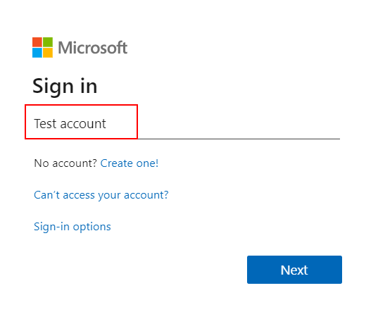

**Note**: Please make sure you have selected the correct environment (with database) when completing the labs. Either use the environment you created in lab 1.1, or the environment provided by your instructor. You can switch between different environments by clicking on the environment picker on the title bar.

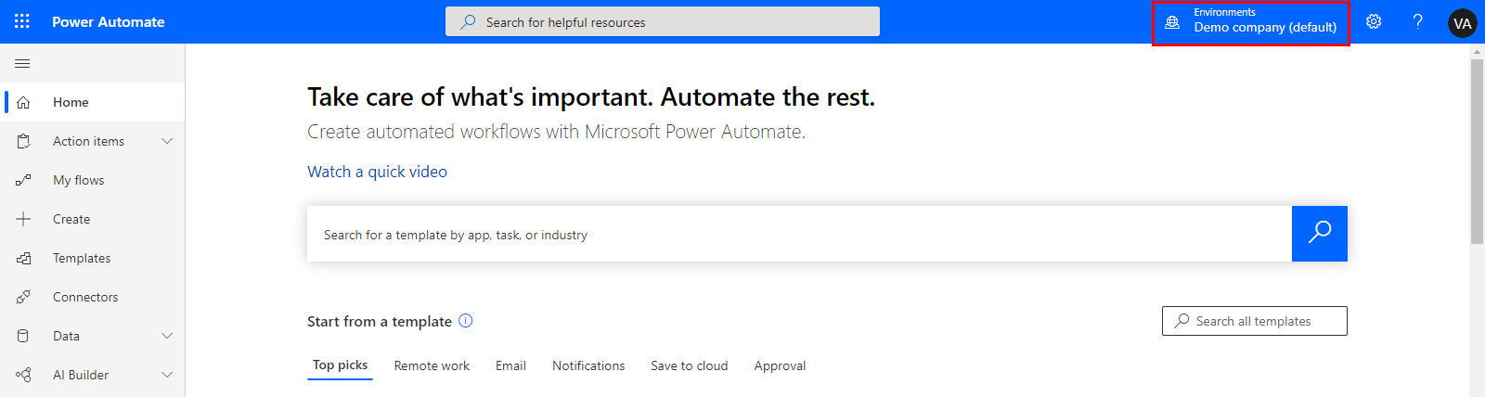

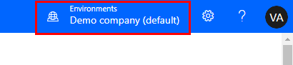

Note**:** To enhance the lab experience, we are going to import an existing solution that includes Process advisor recordings. If you are in a shared environment that your instructor provided to you, your instructor should have already imported this solution for the whole class to use. Proceed to step #11 (click Process advisor) if your instructor has already imported this solution. Otherwise, please proceed with the next step.

1. Click on Process advisor and then Processes. You will subsequently see a Getting things ready message. Allow this process to complete, it will take a few minutes.

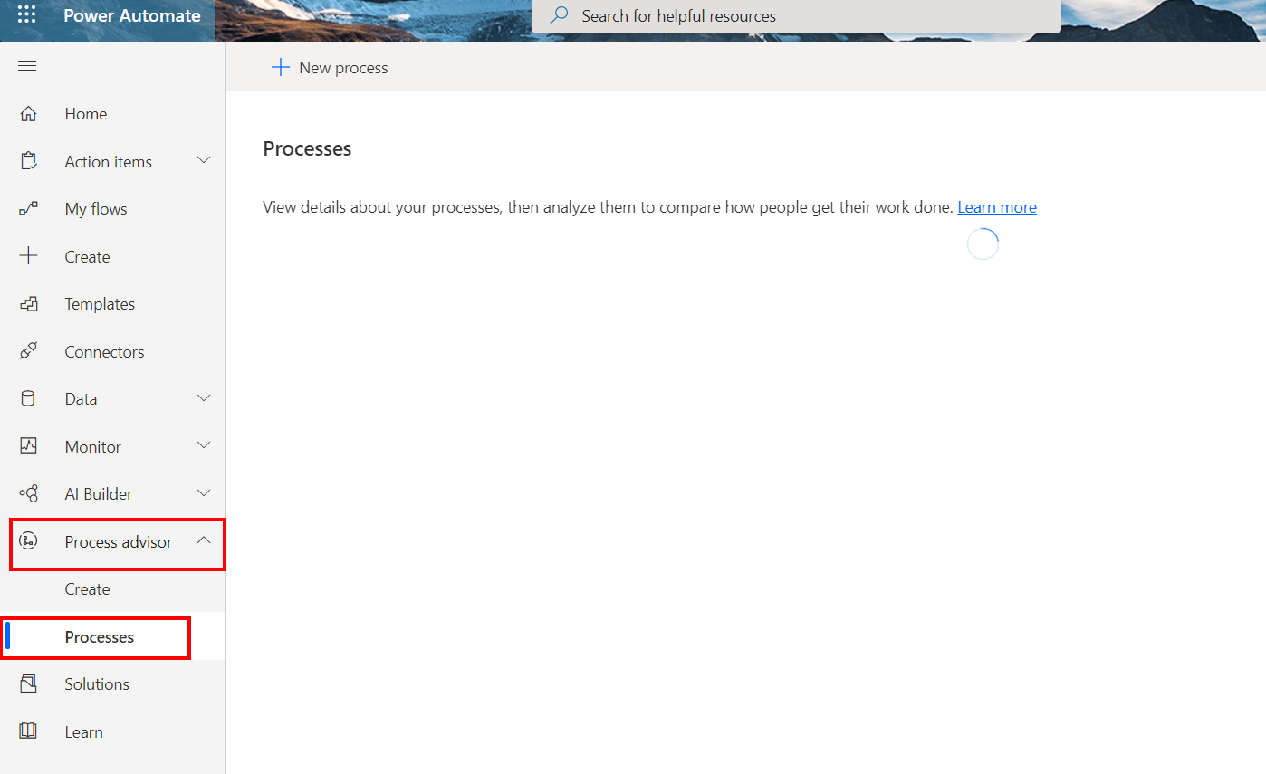

Once this process has completed, you should see the following screen:

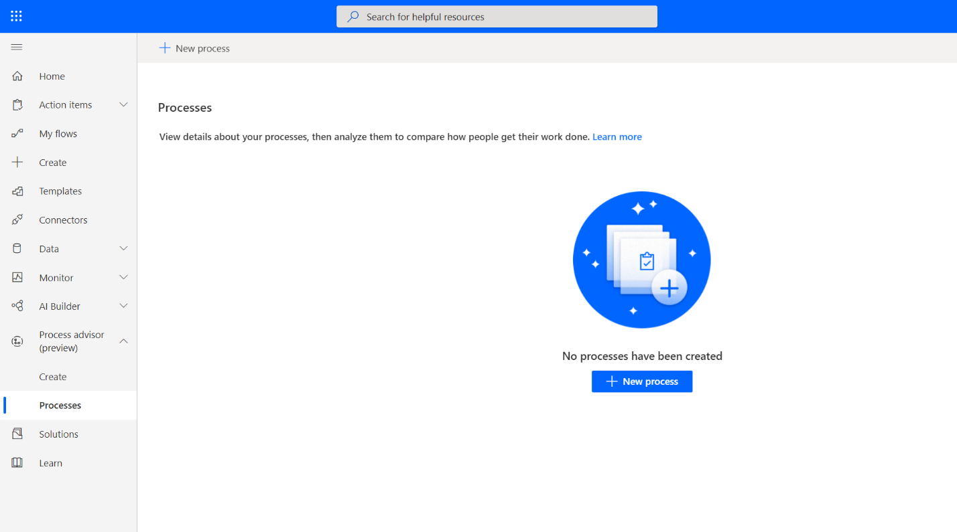

1. Now click Solutions on the left navigation menu

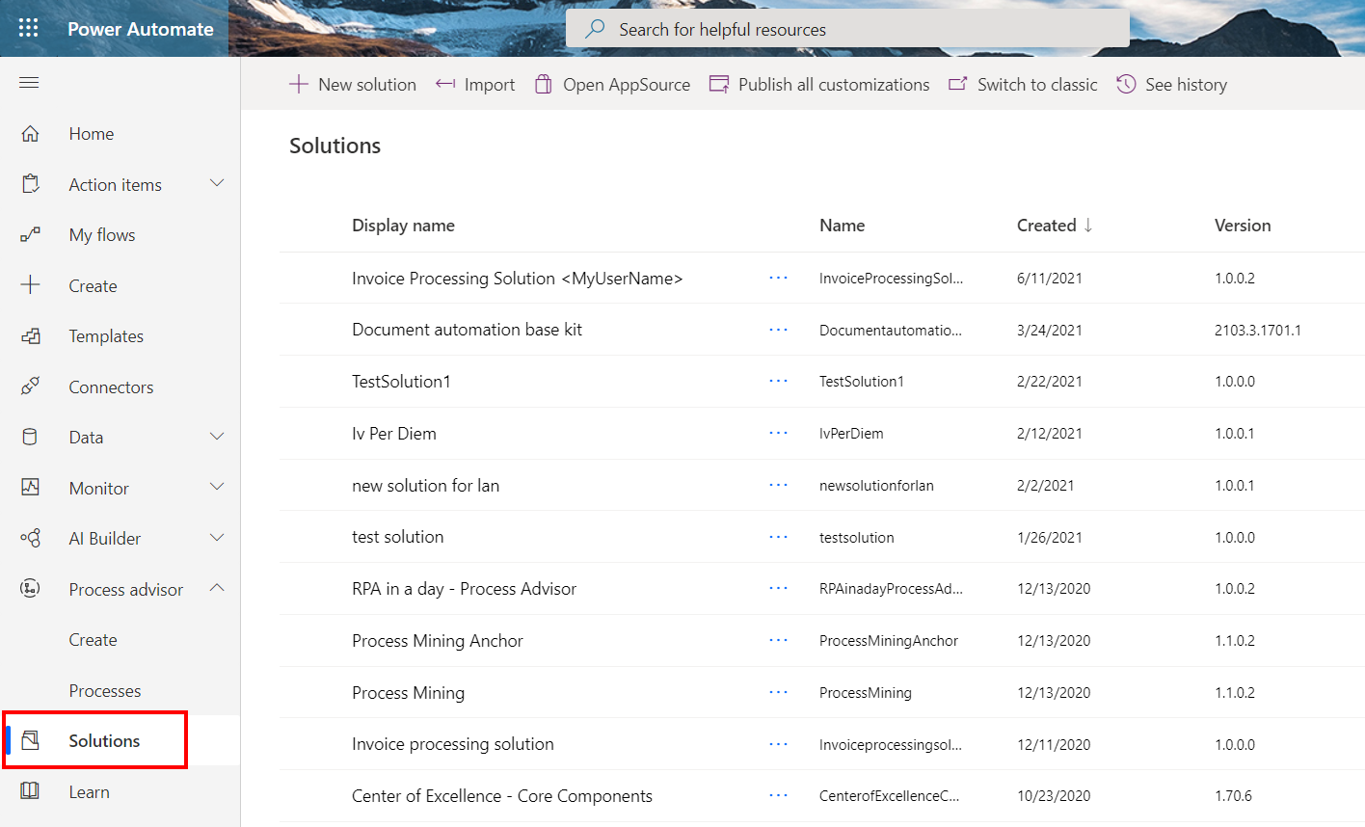

1. Click Import button on the menu

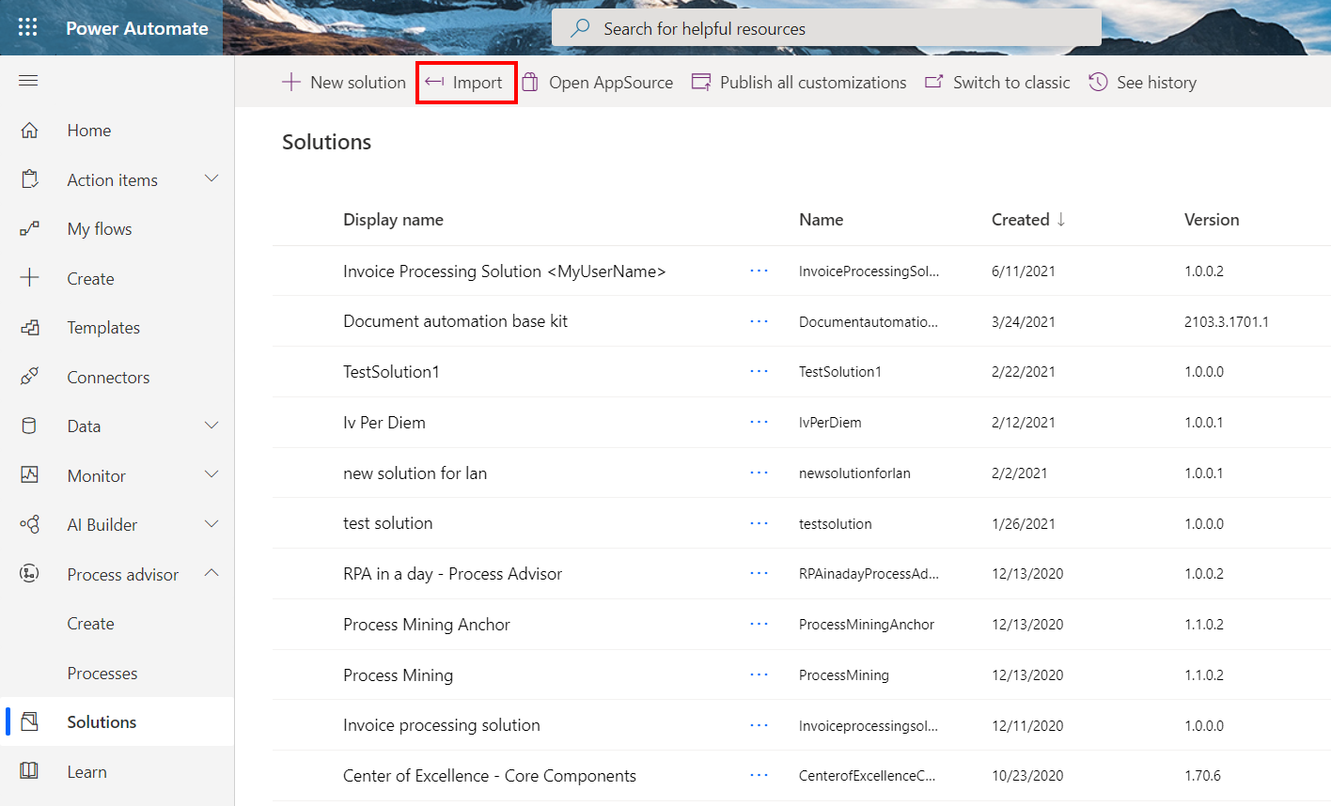

1. Click Browse button

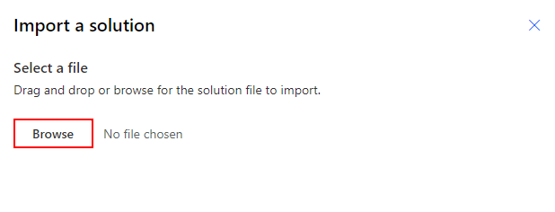

1. Select the RPAinaDayProcessAdvisor[version].zip file from the lab package lab #2 folder and click Open

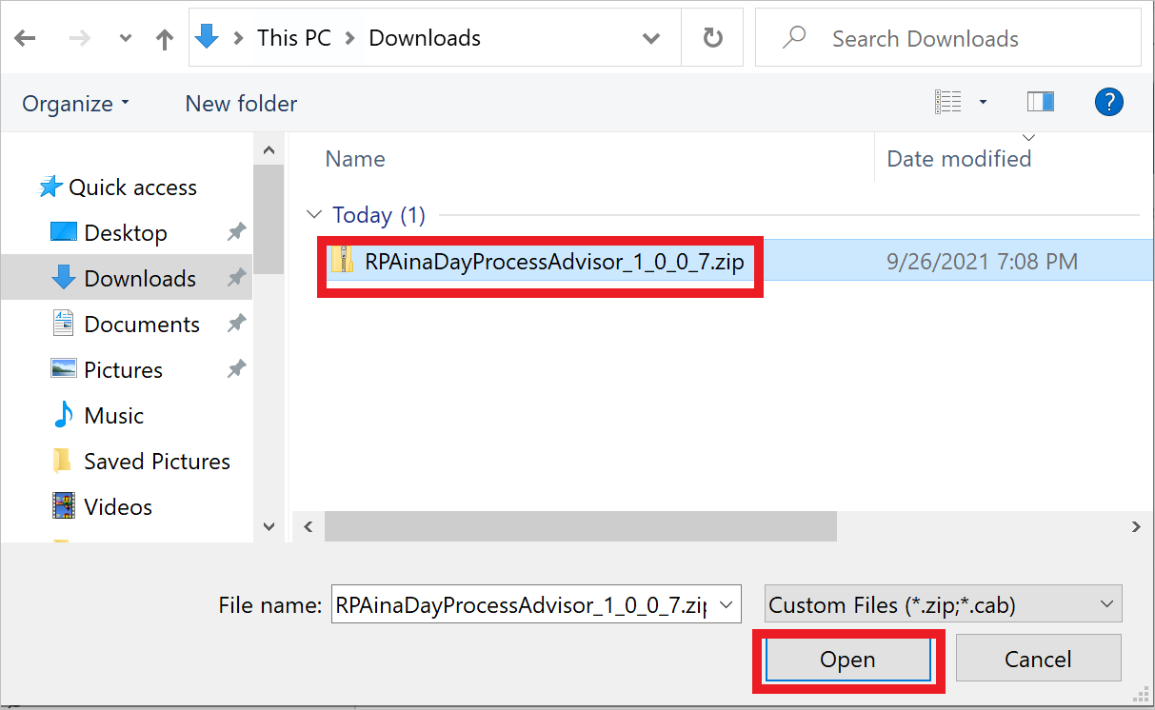

1. Click Next and wait for a few seconds

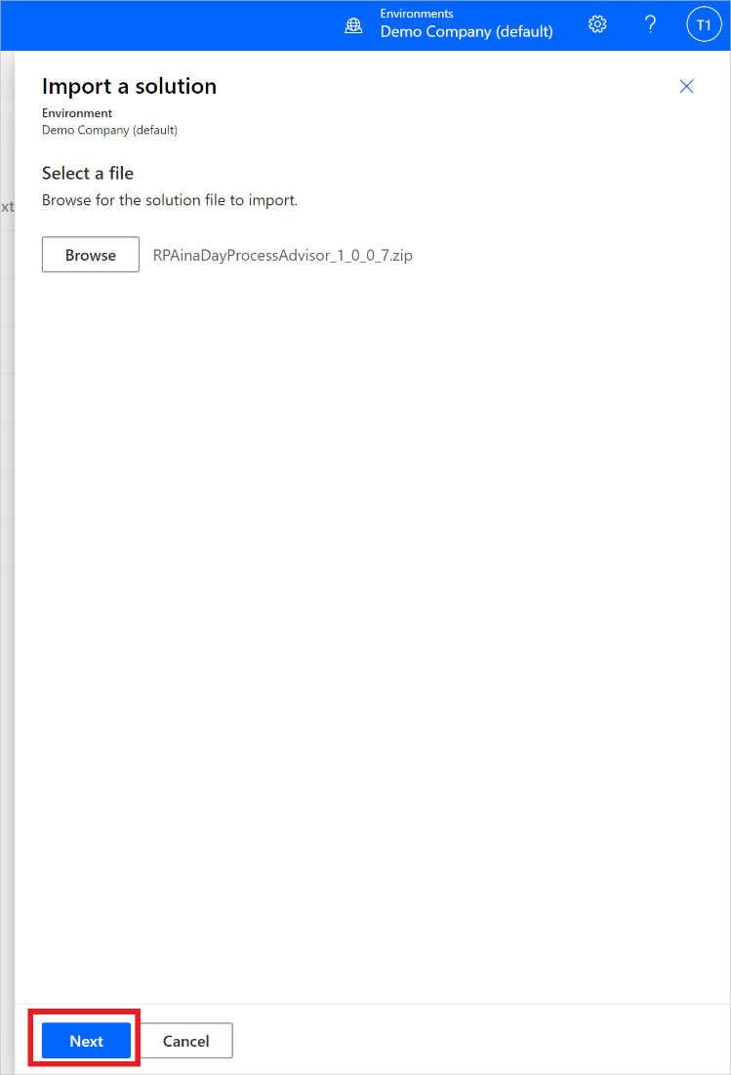

1. Click Import

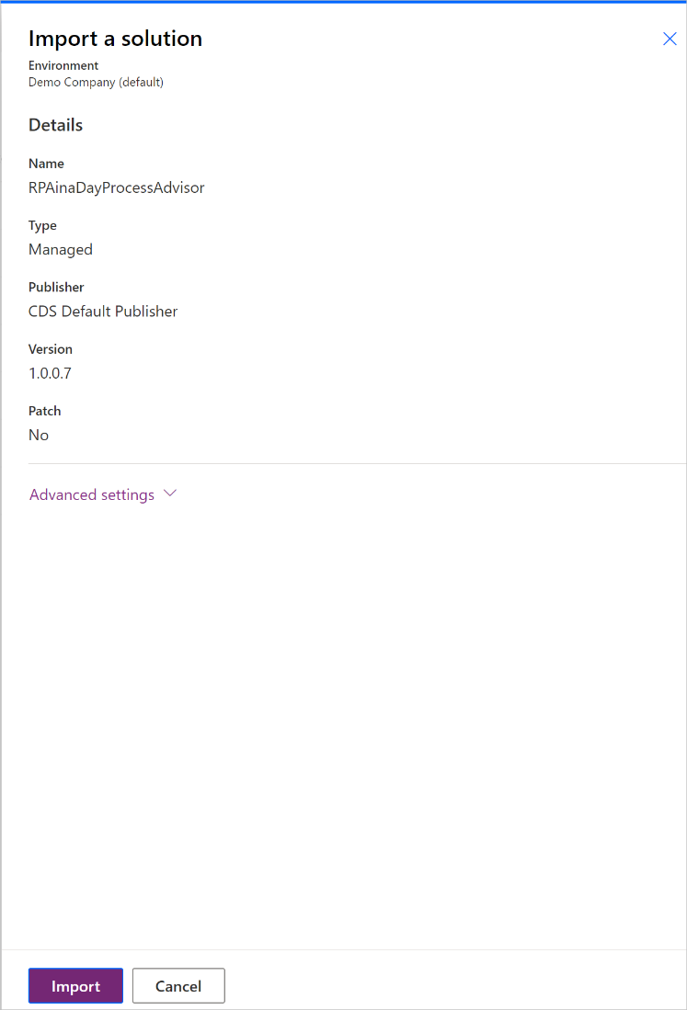

1. After a couple minutes, you should see a confirmation message that your solution has been imported successfully and a new solution called RPA in a day – Process Advisor has been installed.

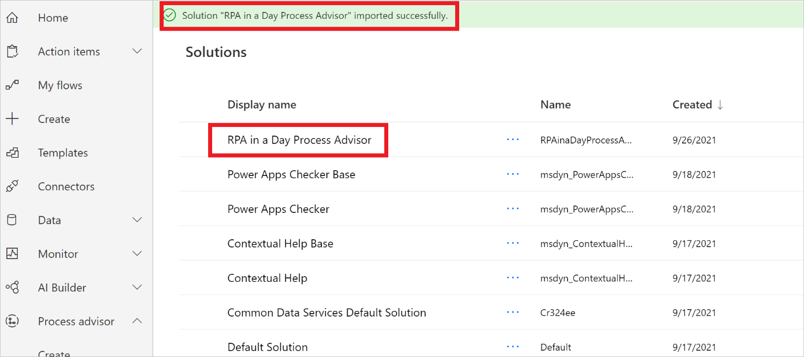

1. Once you successfully imported the zip file, go to Process advisor

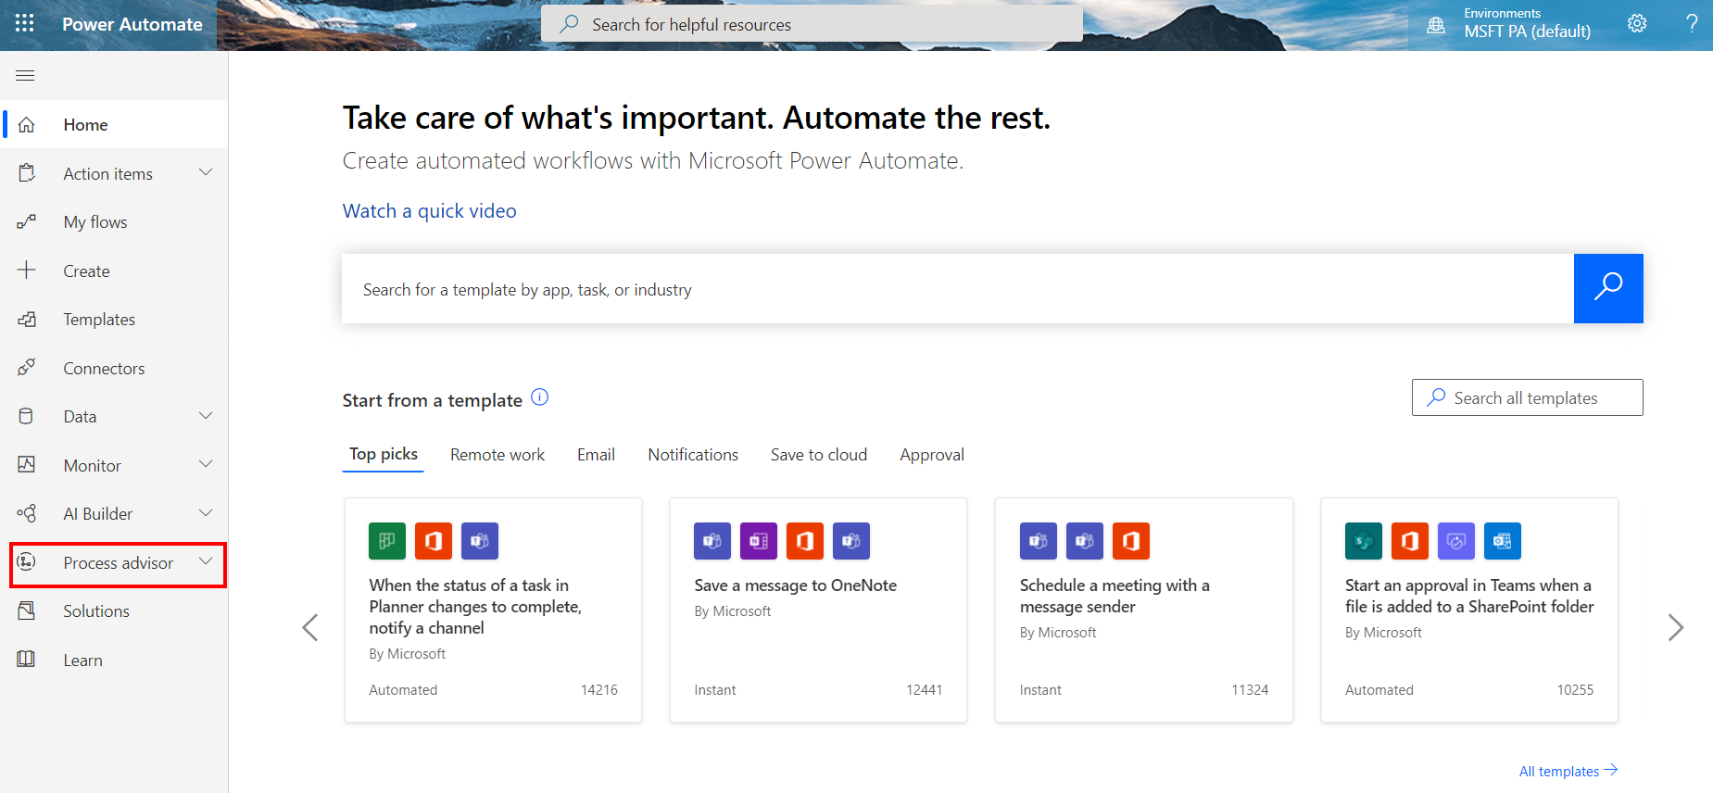

1. Click Processes

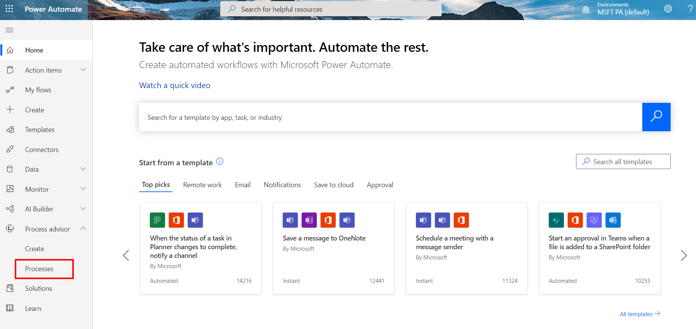

1. Click on Invoice submission Process

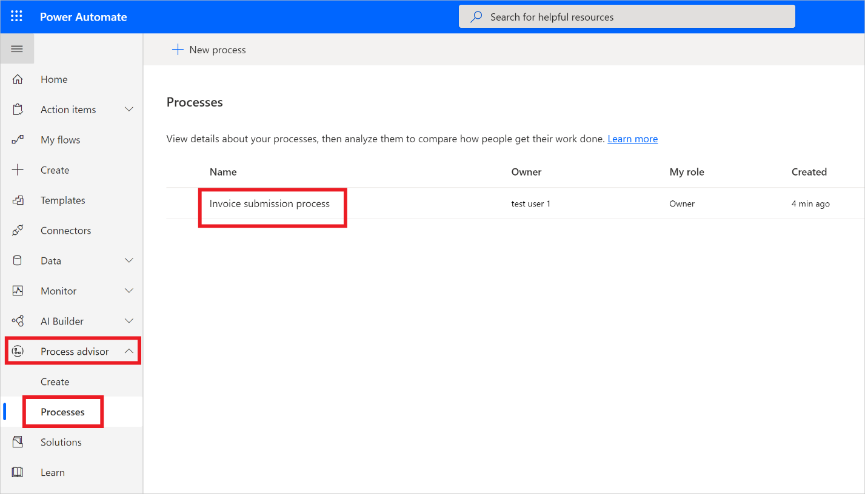

**Note:** If this is the first time you access Process Advisor make sure you have clicked at least once on "Processes" and wait until the "Getting things ready" loading spinner disappeared before importing. If you try to import the RPAinadayProcessAdvisor solution without first initializing the Processes section of Process advisor you will see only a couple of recordings in the imported solution

**Note:** For your first time experience, you might see a tour box open, you can either complete the tour or skip the tour.

1. You can see all the existing recordings under Recordings

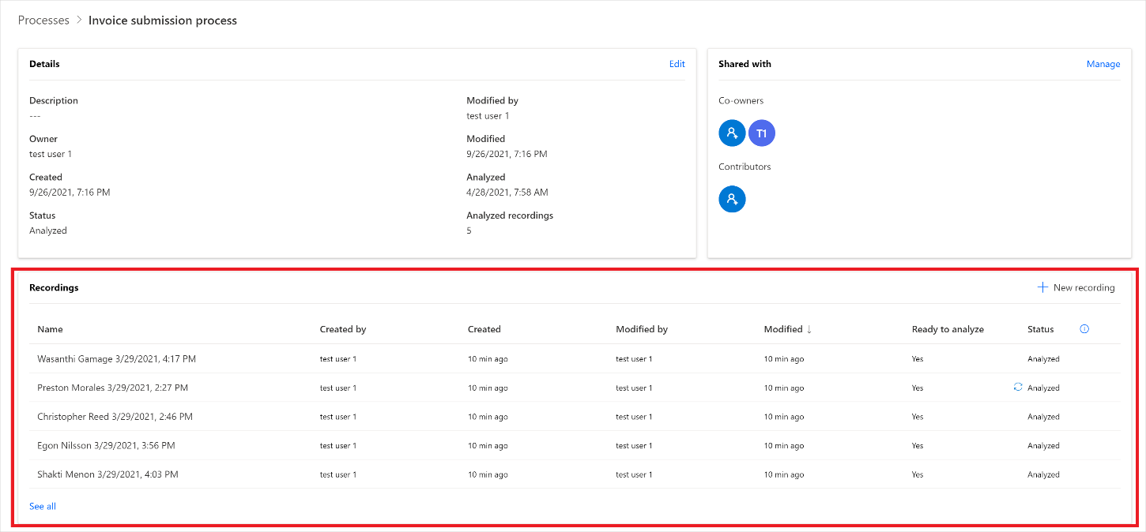

1. Click See all, you will be able to see all the existing recordings

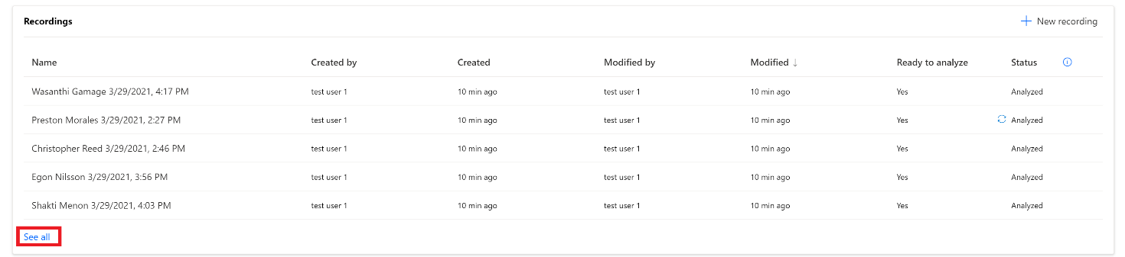

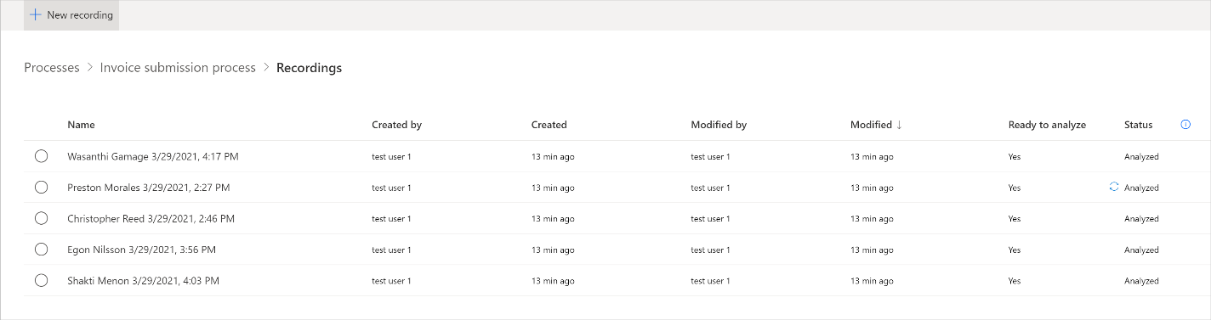

1. Let’s go back to Invoice submission process by clicking Invoice submission process

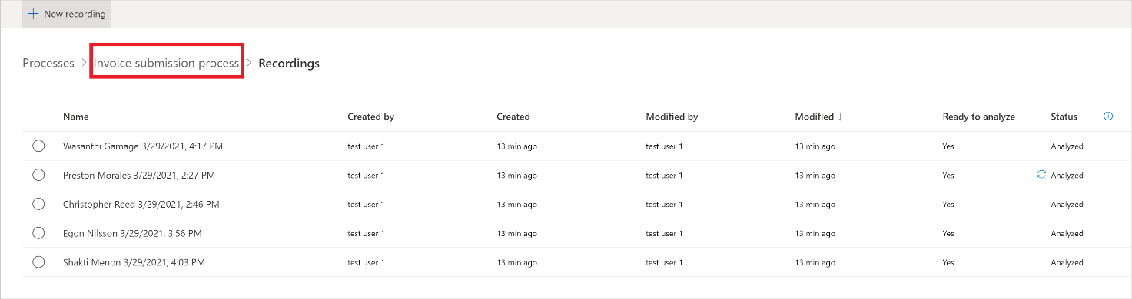

1. You will be able to see below features:



* + New Recording - You can create a new recording by clicking + New Recording (We will create a new recording in an upcoming exercise)



* Analytics - You can see the process map and insights by clicking Analytics



* Share - You can share your processes with your team members by clicking Share



**Note:** Process owners can pick two role options when sharing: contributor and co-owner. The contributor role would only give the user the ability to upload their own recording to the process. The co-owner role would give the user the ability to upload recordings and edit other recordings.

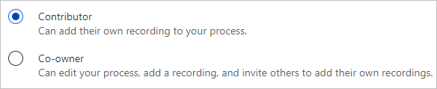

* Analyze - You can click Analyze to analyze your processes



* Create activity names - You can create activity names by clicking + New name for you process



* Delete - You can delete your Processes by clicking Delete



1. Now, let’s click Analyze to analyze our processes. When we perform this action, Process advisor is going to analyze existing recordings to identify any bottlenecks within the business process.

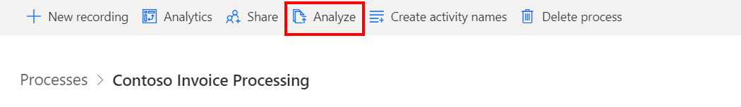

1. Click Confirmto proceed.

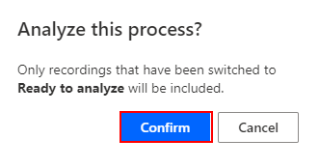

1. The analysis will take a few minutes to complete. During this process, a status message is displayed under the New recordingbutton. If you run into an error during the analysis stage, click Analyze to trigger this action again.

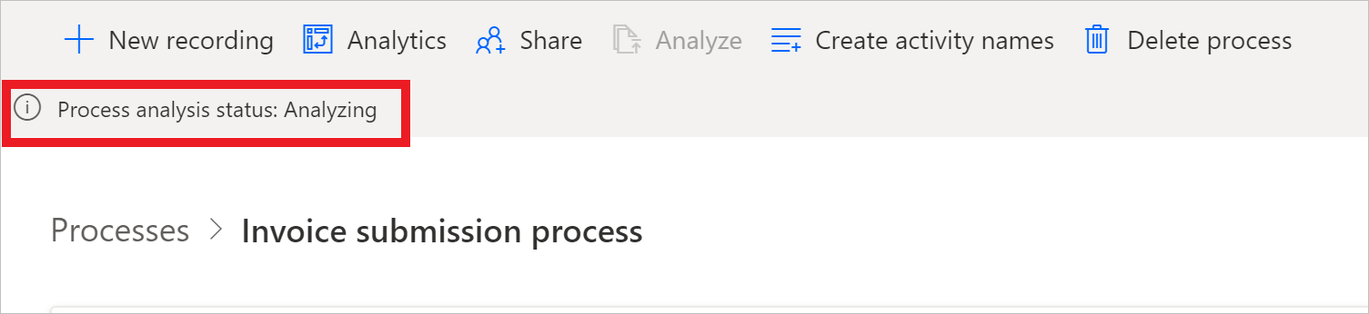

1. Once it is done, you will see the Process analysis status will changed to Analyzed. Click Analytics to see Contoso Invoice Processing process map and insights. This step may take a couple minutes to complete after the analysis has been performed.

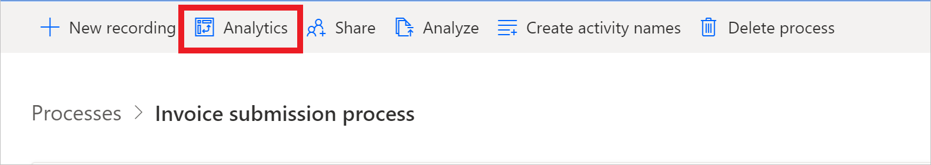

1. Let’s take a look at the analytics page layout:

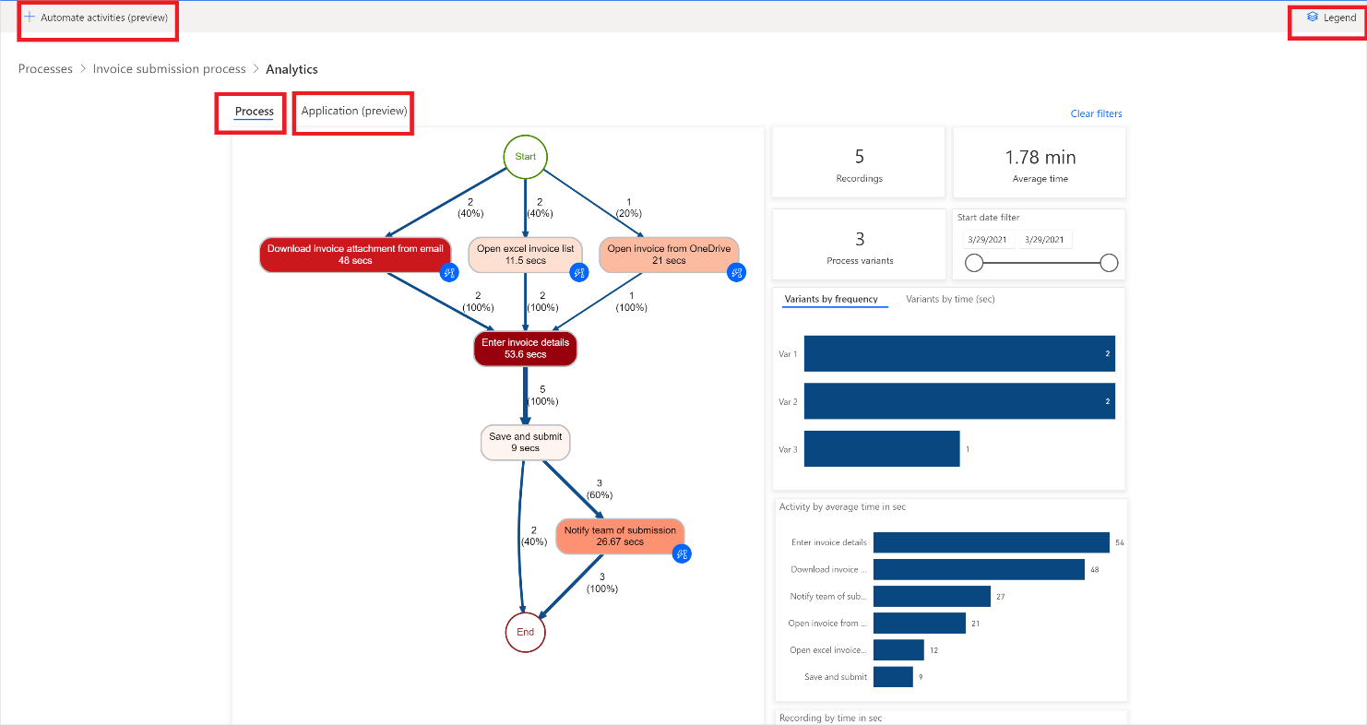

1. Automate activities (preview) – if during the recording process, user used an application, that has its Power Automate actions, for example Outlook or Excel, then after pressing the button, a draft Power Automate process would be opened containing already actions related to used applications which can be automated. Users would then be able to start building the final process using the proposed draft.
2. Legend – display information about the report, to let users better understand what they see:
3. Process – part of report that delivers detailed information about the analyzed process. Here users can find process map, general information about the process: time analytics per variant and per the recording’s author.
4. Application (preview) – delivers information about the apps used in recordings. What apps were used by authors, how often were they used, what were the transitions between them. This report explains what connectors should be used when implementing automation for the process as well as where potentially to use Power Automate Desktop as there’s no connector existing.
5. We can see the various steps in our business process and their related durations. These steps include:
   1. Download invoice attachment from email (48 seconds)
   2. Open excel invoice list (11.5 seconds)
   3. Open invoice from OneDrive (21 seconds)
   4. Enter invoice details (53.6 seconds)
   5. Save and submit (9 seconds)
   6. Notify team of submission (26.67 seconds)
6. Let us take a closer look at the process map

The process map makes it possible to visualize and analyze processes. By looking at a graphical representation of how your business processes are performed, you can gather insights about where improvement opportunities exist. To get to the process map, go to Analytics and select Process map tab.

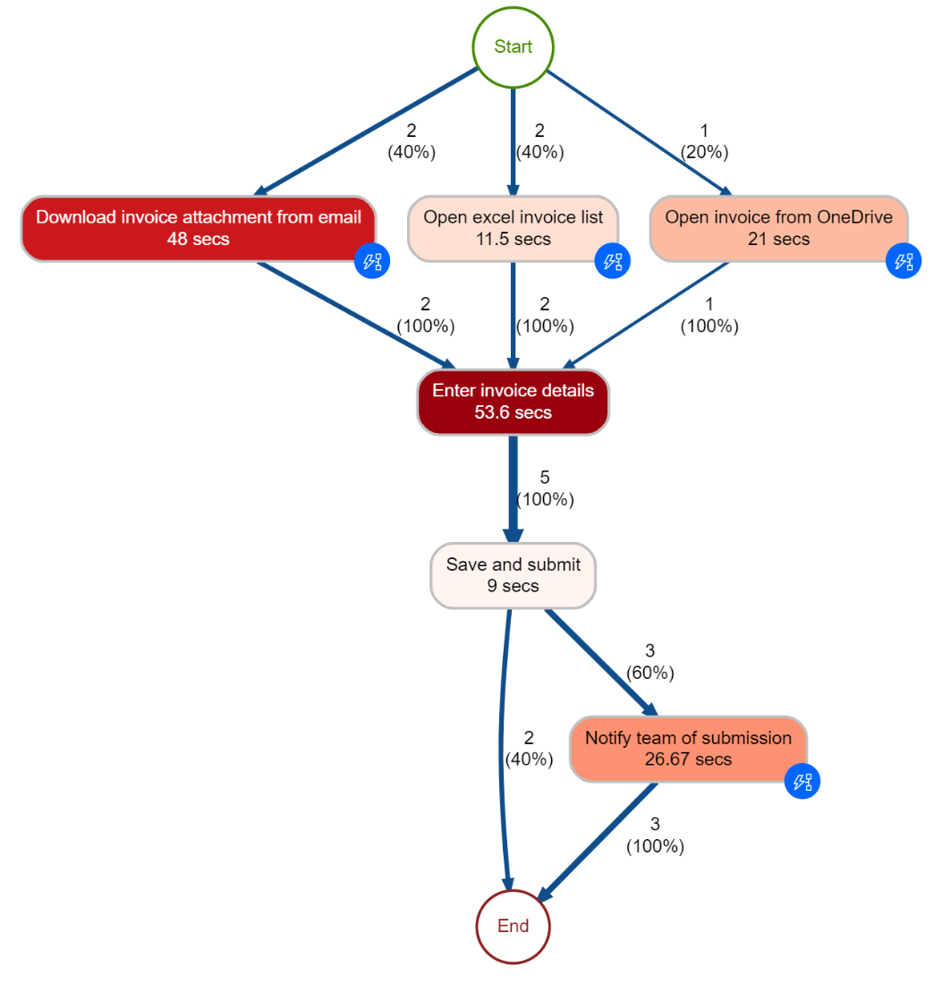

1. Let us take a closer look at the Variant by frequency bars on the left

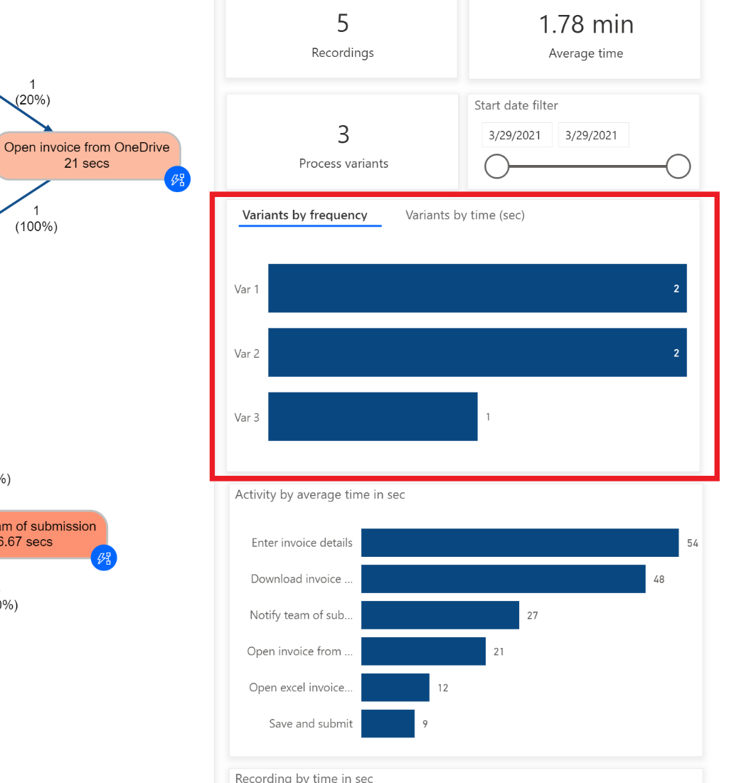

Different activity combinations and variants are shown separately on the process map. A process variant is a unique path from the very beginning to the very end of the process. In other words, a process variant is a specific activity sequence, like a “trace” through the process, from start to end. Each variant differs from the others by at least one activity. You can see additional metrics, frequency of the activities, as well as throughput time, on the process map. Frequency shows you the total number of recordings/cases passing through it. Throughput time is the time between the very first event of the case and the very last.

1. Click on the most frequent variant (the 1st blue box under Variants by frequency)

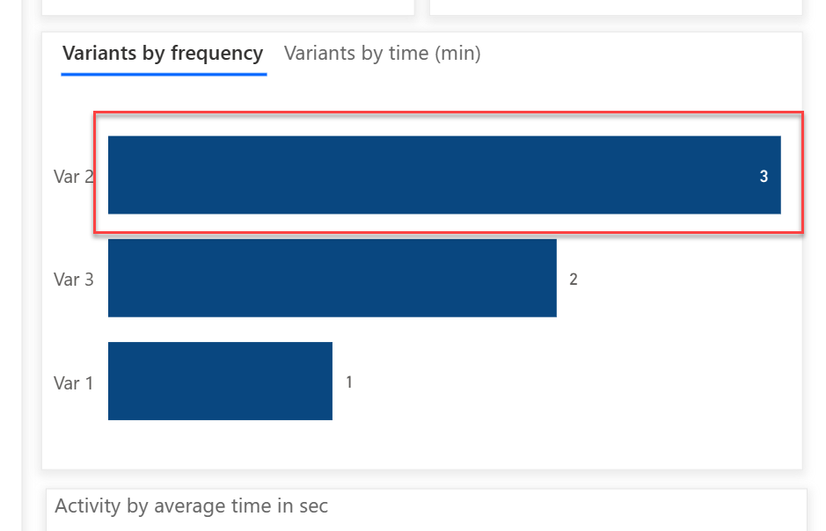

1. You can see that the invoice coming through email is the most frequent process variant.

Note: It might take a while for you to see the changes from the chart

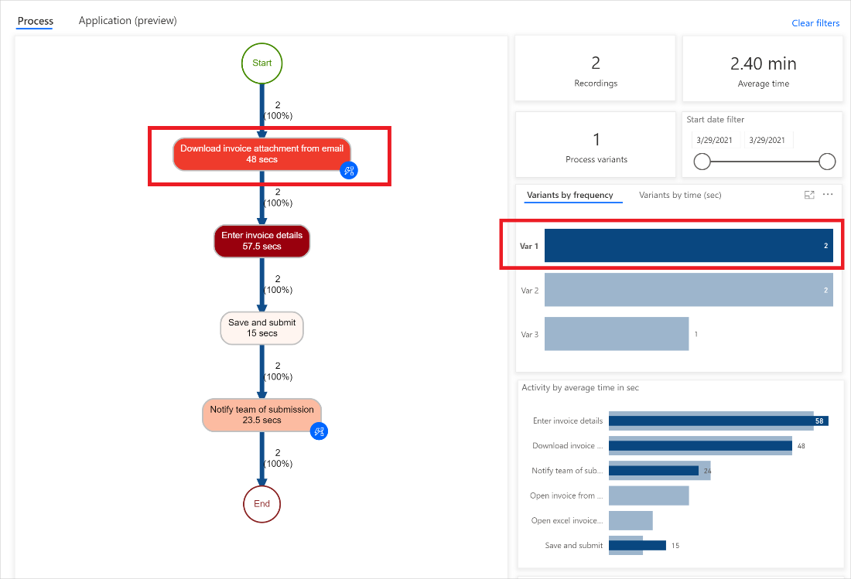

1. Additionally, we can see people spend a lot of their time entering the information in the application. This helps identify the opportunity to automate the process.

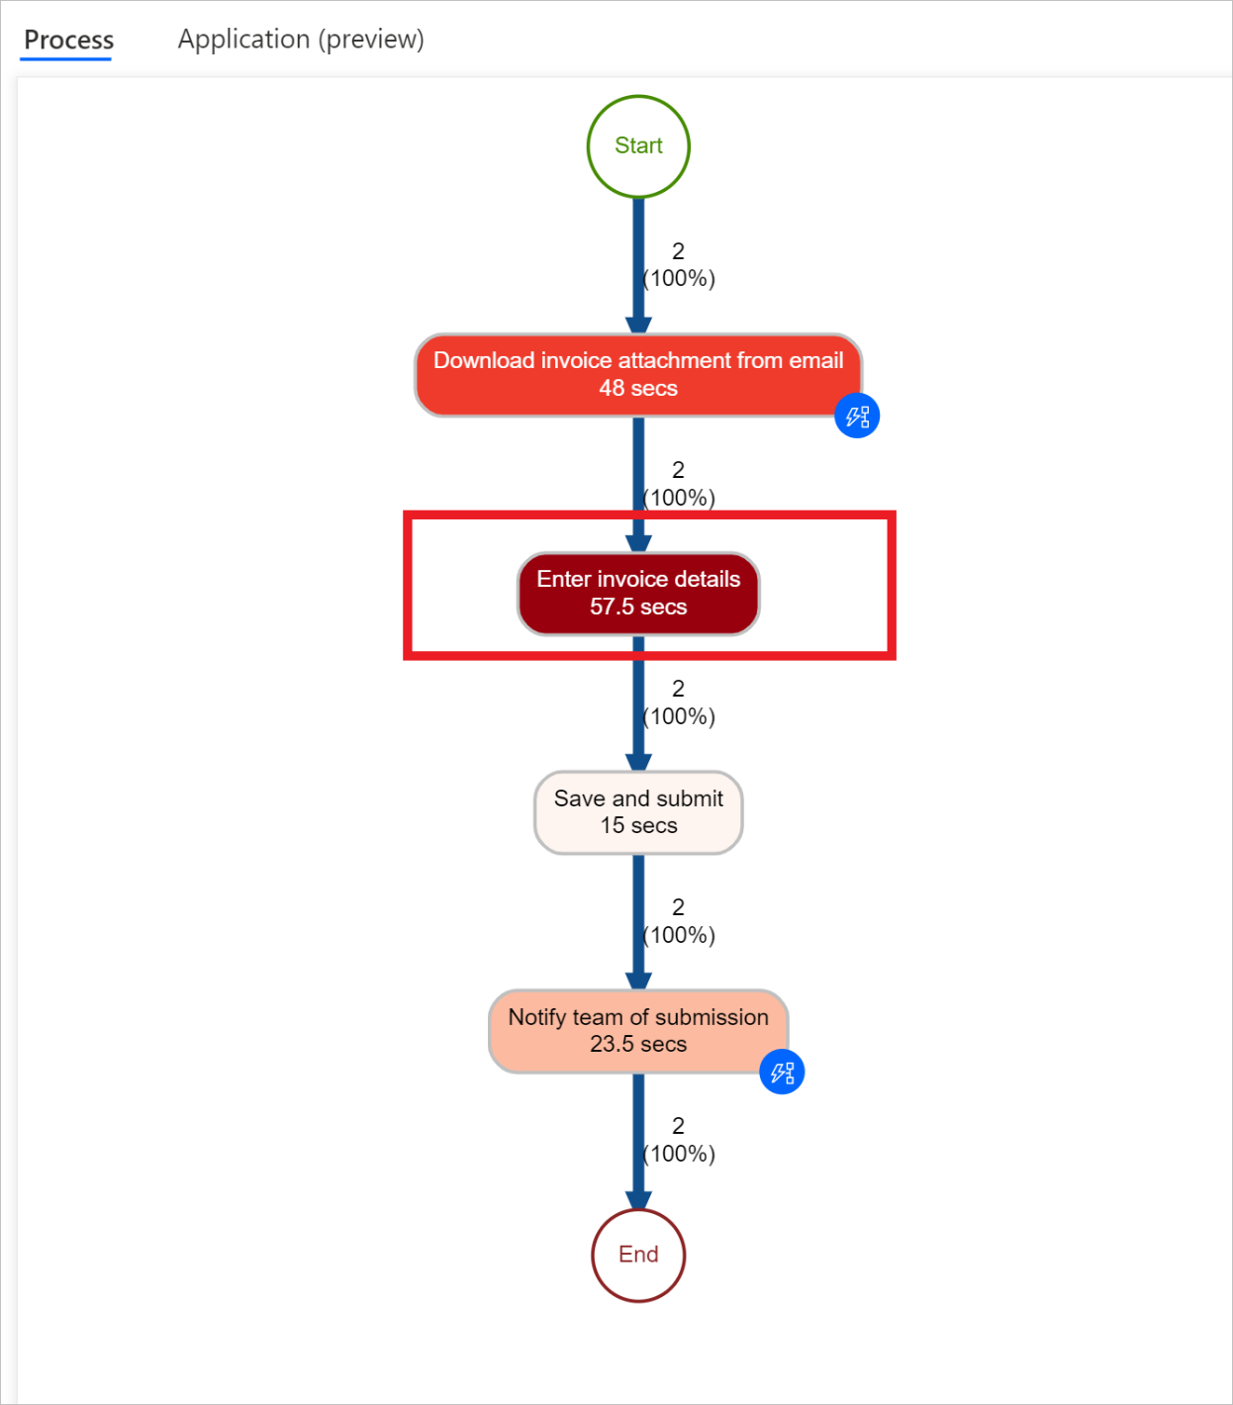

1. Let us click any blank space within the **Variants by frequency** area to unselect **Var 1** option

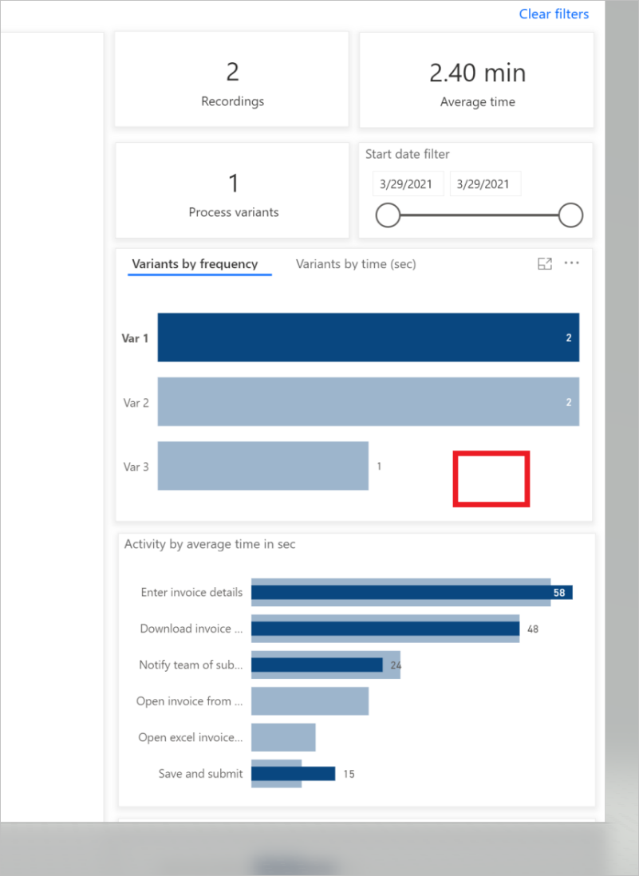

1. Now let us take a closer look at the top analytics data. We can see that the average this process time is 1.78 mins out of 5 recordings.

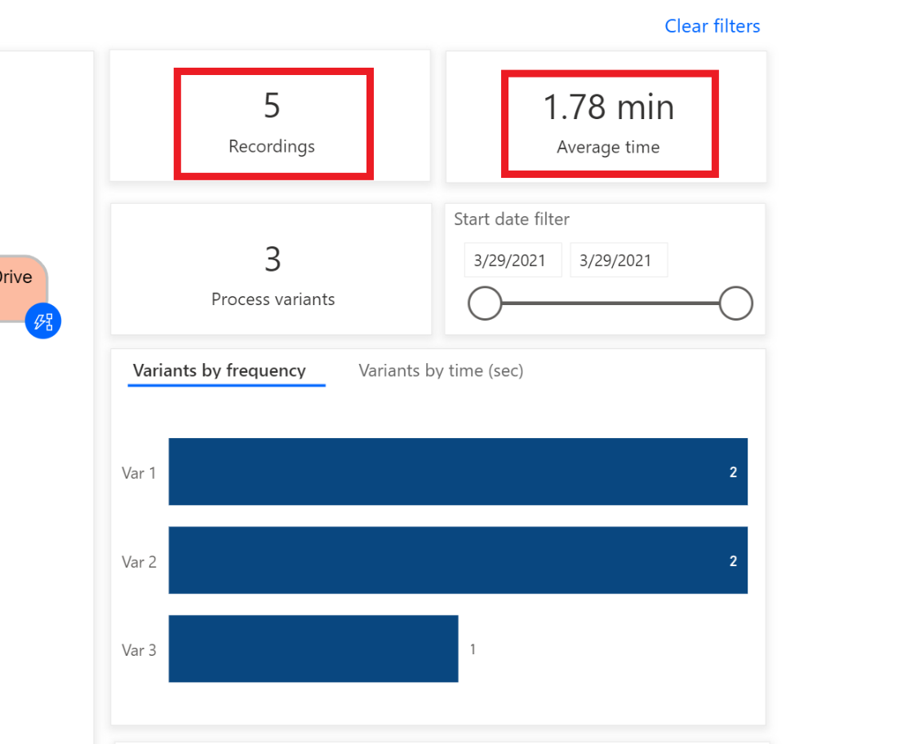

1. We can also see other different time-based metrics dashboards

* Activity by average time in sec

You will notice that Enter invoice details and Download invoice are taking the most time

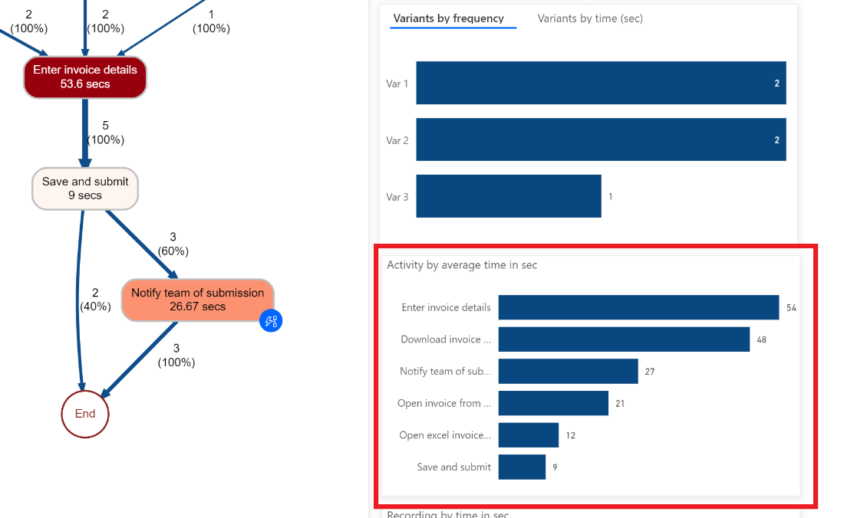

* Recording by average time in min

You will notice that some people Preston Morales and Shakti Menon are taking more time than others

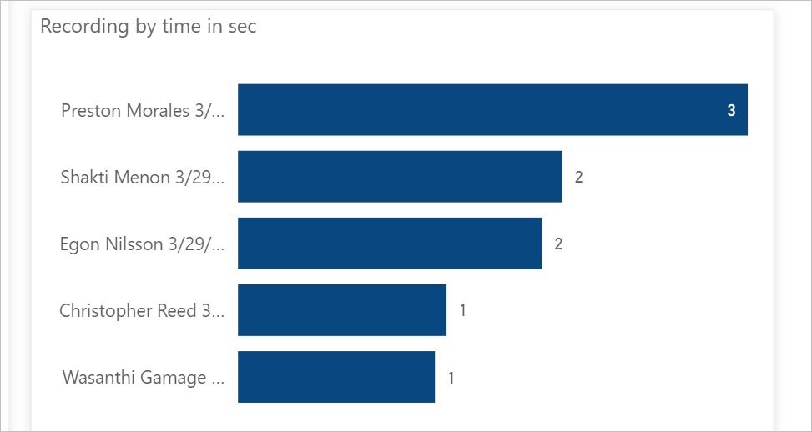

1. Now let us click the **Application (preview)** tab where we can see details on which applications were used**.**

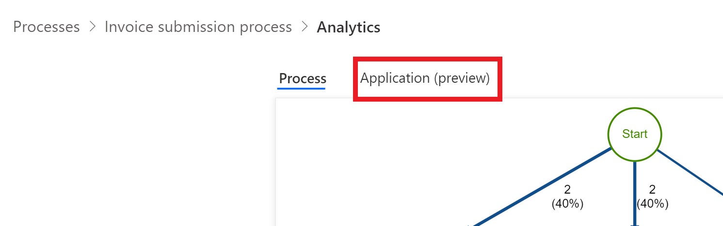

Note: It might take a while to load the reports

* This report is important as it allows you to discover insights into the different applications used in a business process, the frequency with which they are accessed, and how much time is spent on the application.
* For example, the dashboard shows that a legacy invoicing app, outlook and excel have significant contribution to time spent and actions by applications.
* Please take some time to get familiar with the different reports here

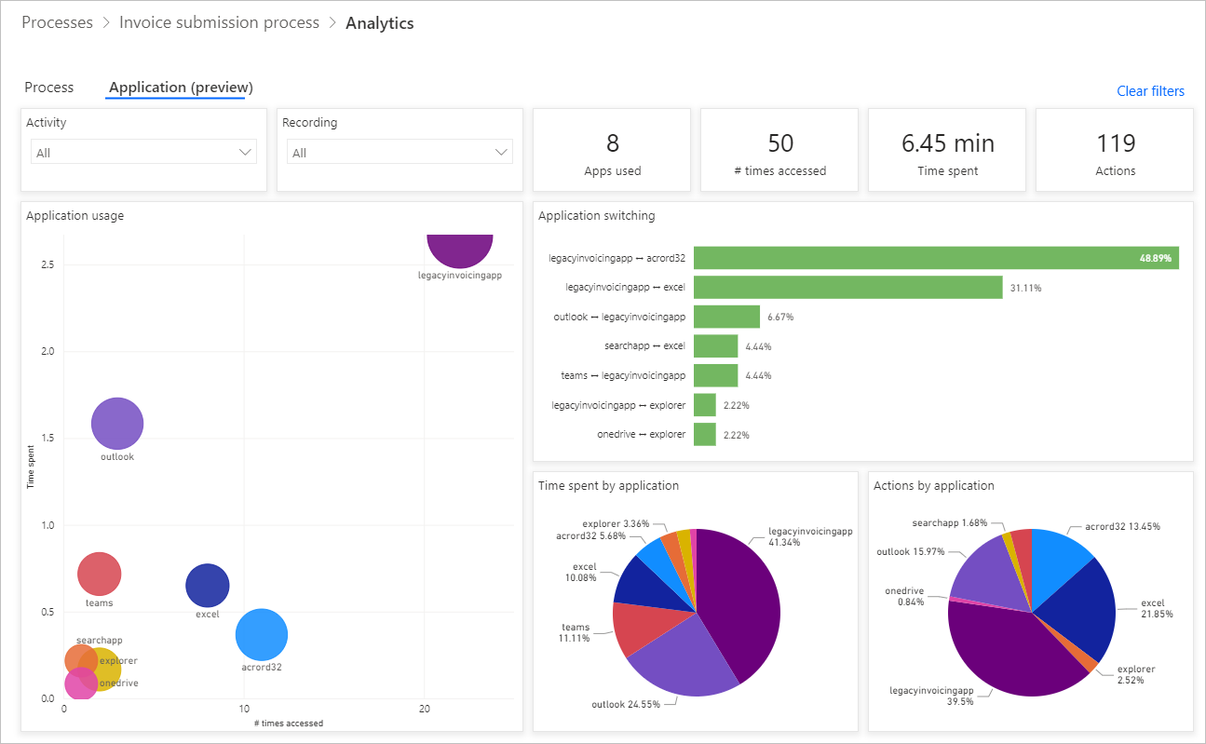

1. Now click on **Process** tab to go back to the process map.

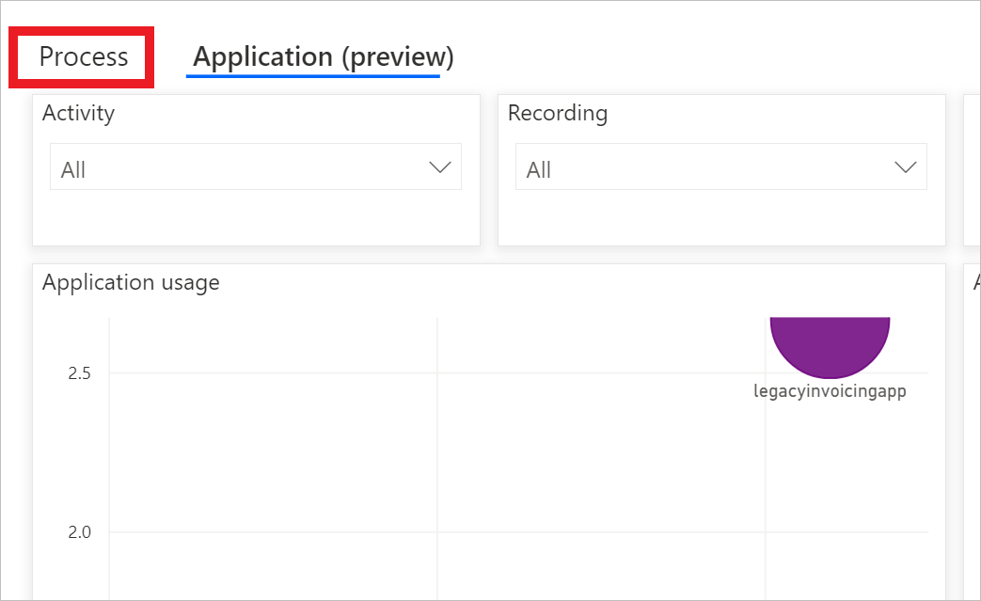

1. Next let us take a closer look at the Automate activities feature. From the process map, we can see that Process Advisor has highlighted several activities as potential candidates for automation based on applications involved inside the small blue circles.

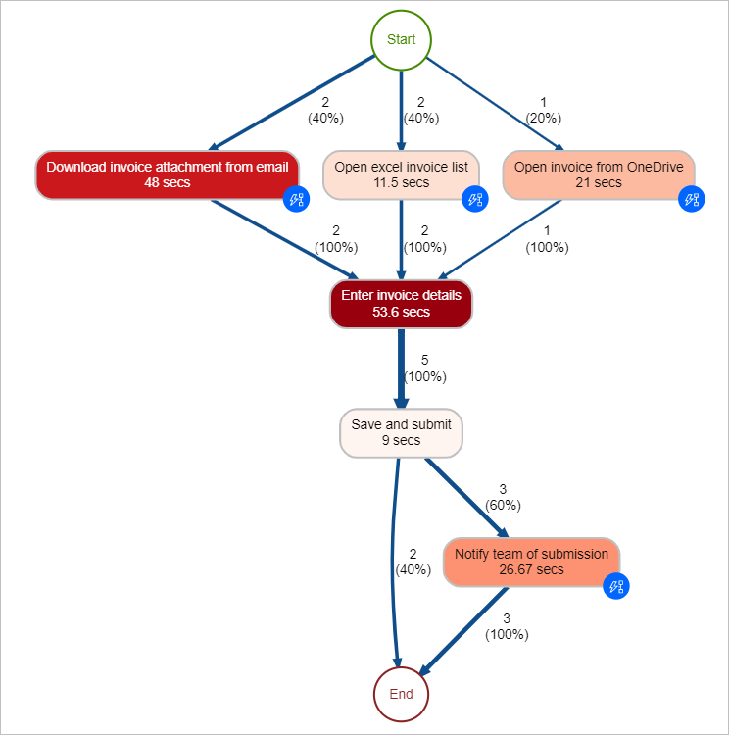

1. Click on **Automate activities (preview)** button on the top to start creating a flow for automation.

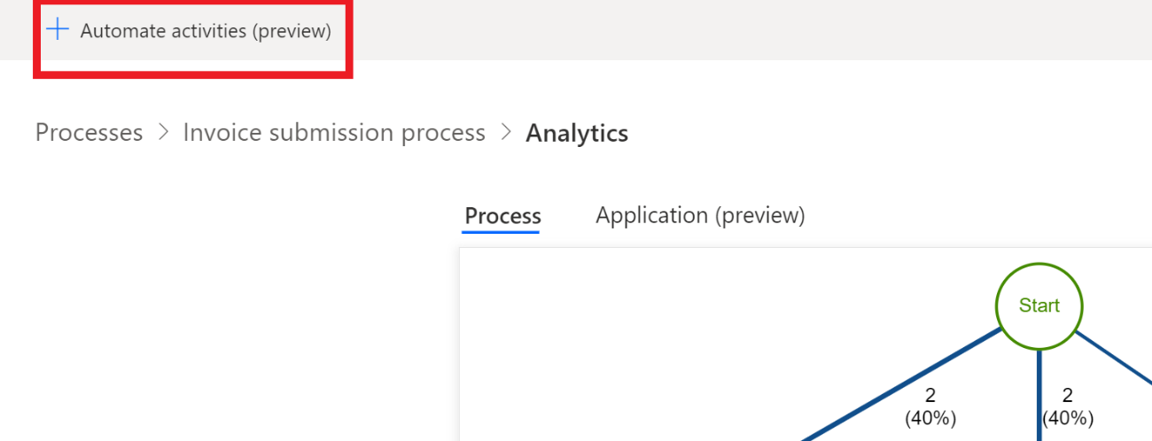

1. A new tab will open in the browser and bring you into the flow designer. We can see that the recommended actions by Process Advisor automatically showed up on the right panel that match to the activities from the process map. For example, several Email connectors are suggested to you for automating the **Download invoice attachment from email** activity. We will go into more details on how to build flows in the subsequent labs.

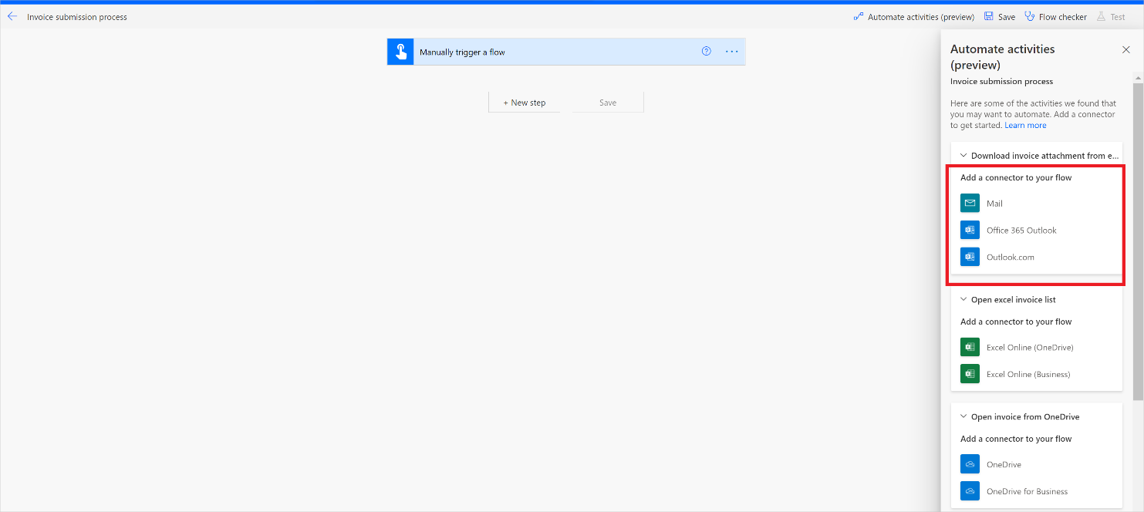

Create your first recording

1. Now, we will learn how to add new recording to a Process. Go back to the browser tap with the Process Advisor page open
2. Go back to **Invoice submission processing** processes by clicking the process name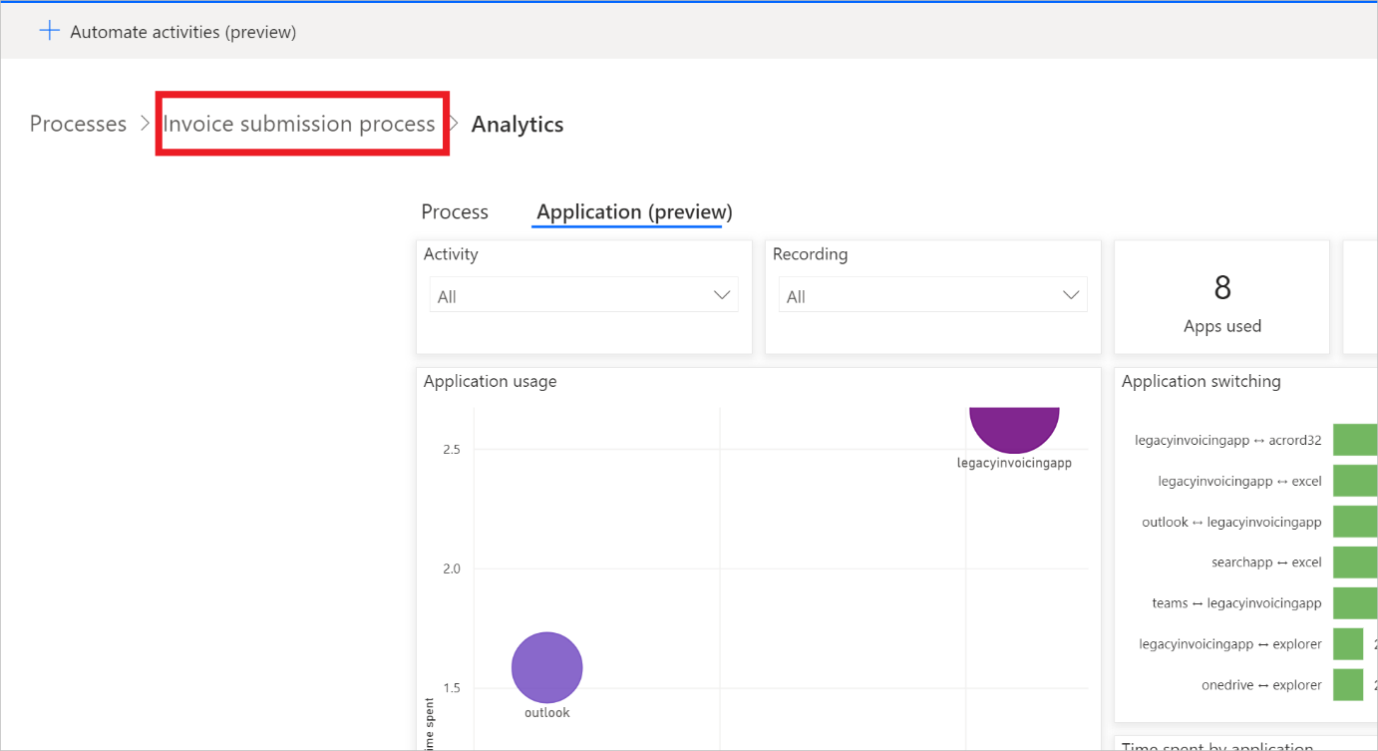
3. Click + New Recording to create your first recording

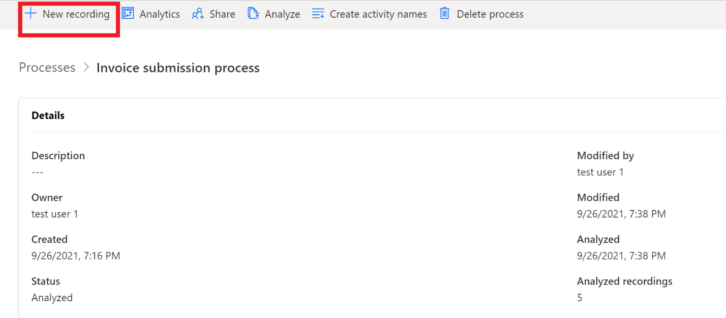

1. Select Invoice submission processing under Process, then click Open recorder

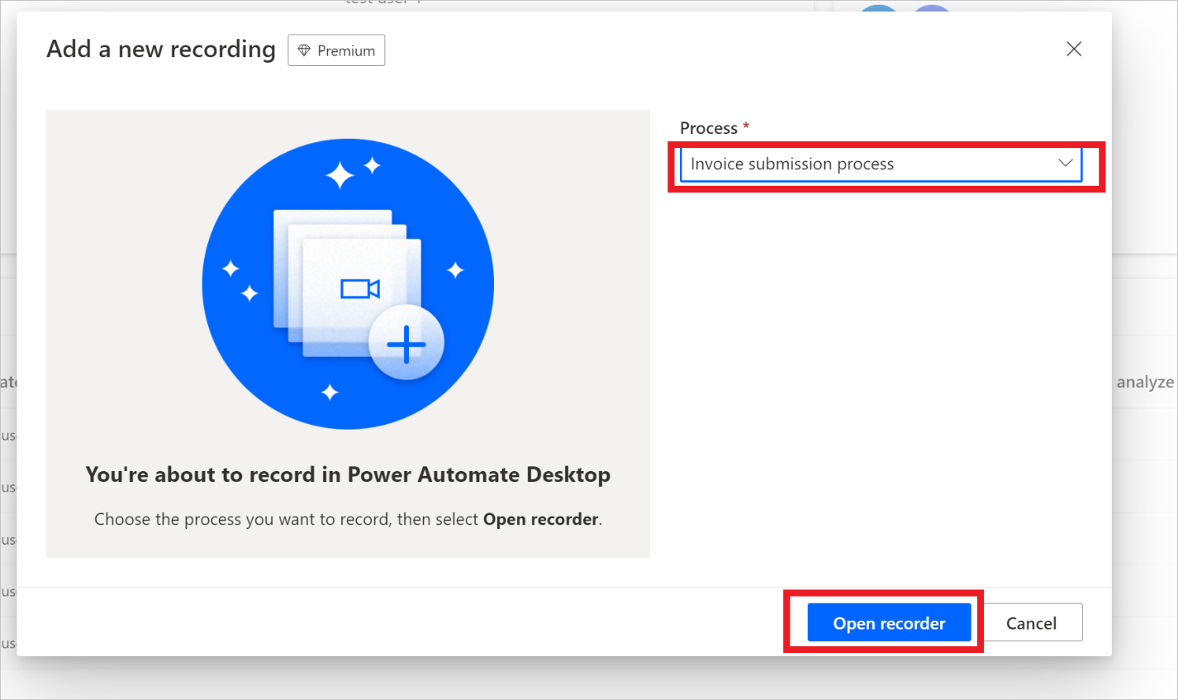

1. You will see this pop-up window that is trying to open Power Automate Desktop app, check **Always allow** click Open Power Automate Desktop

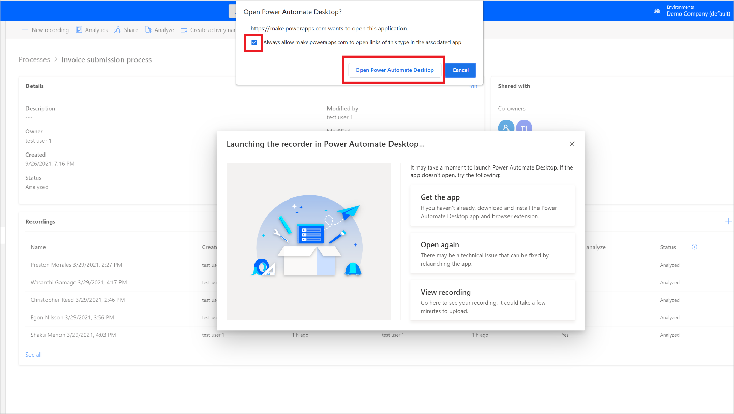

1. If asked, sign in with your test account

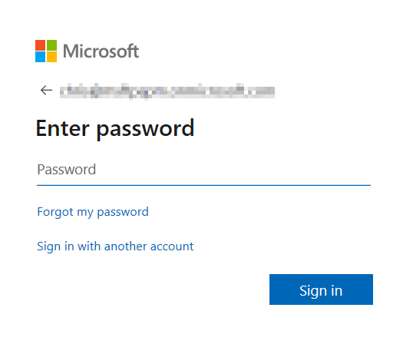

1. Now you should see a Desktop recorder UI shows up on your machine

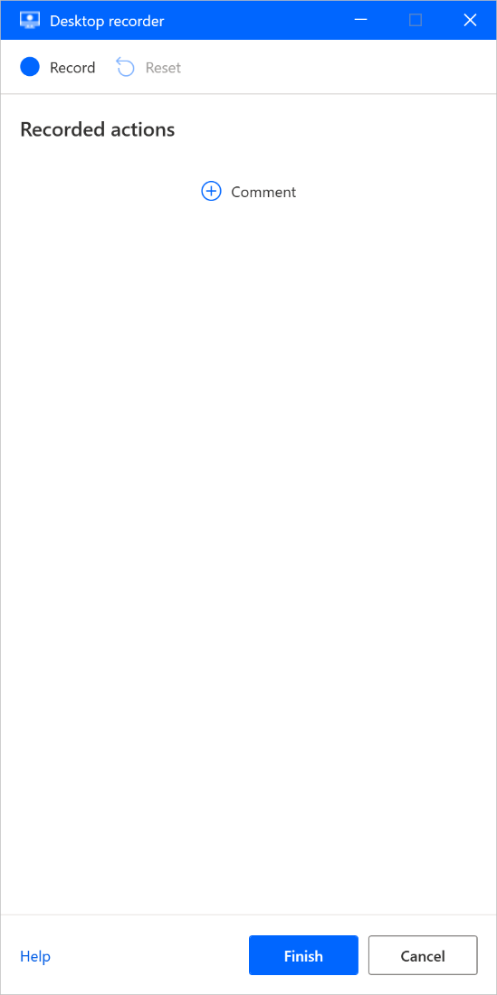

1. Now open the Contoso Invoicing app that you downloaded in pre-requisite 1.3

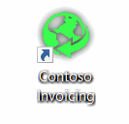

Tip 1: We are going to start recording. It is strongly recommended you read and get familiar with steps below first before you begin recording. This allows you to finish the recording in one shot without the need to go back and forth with this manually which may alter results. If your first few recordings were not very good. Feel free to delete the recording after (using the … icon) and practice more until you have a good recording

Tip 2: to help with the resilience of UI automation playbacks, it is recommended to minimize other apps from your desktop

1. In the Desktop recorder app, click Record. Recording will start now to record any mouse or keyboard actions you are performing.

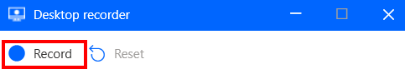

1. First open the Contoso Invoicing app, click Invoices button

Tip: As your mouse hovers over controls in the app, you'll notice that a red outline highlights each control. Don’t record at very fast speed and always wait a bit between each mouse move and click, until you see the blue highlight rectangle around the control first, before you click to select the control. If the red highlight did not show up before you clicked, the action may not be recorded properly

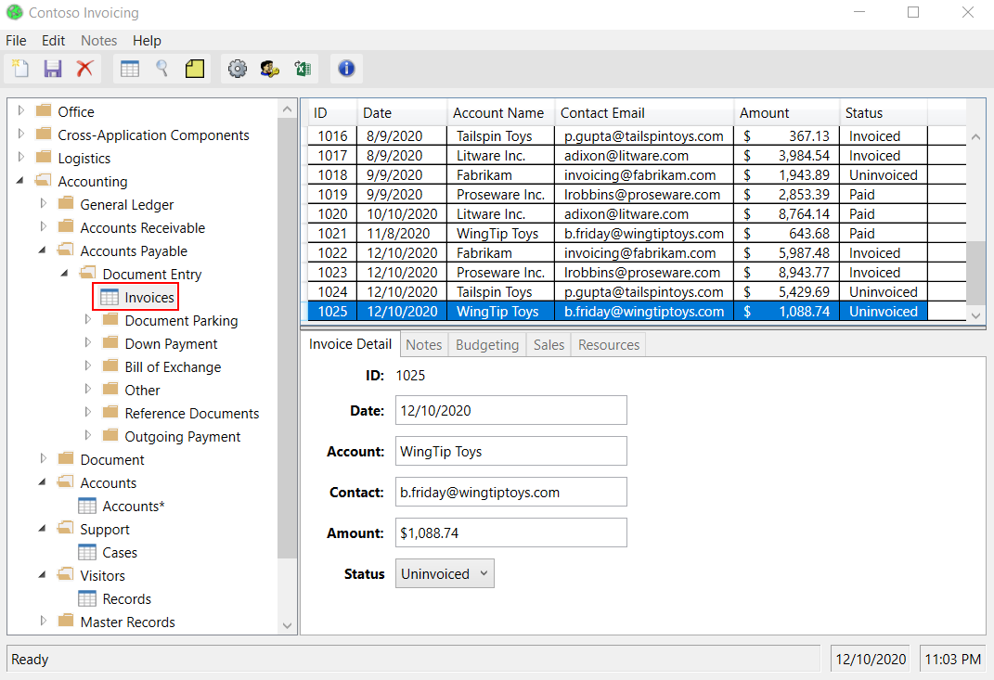

1. Create a new record by clicking the New record icon on the left of the menu bar on the top

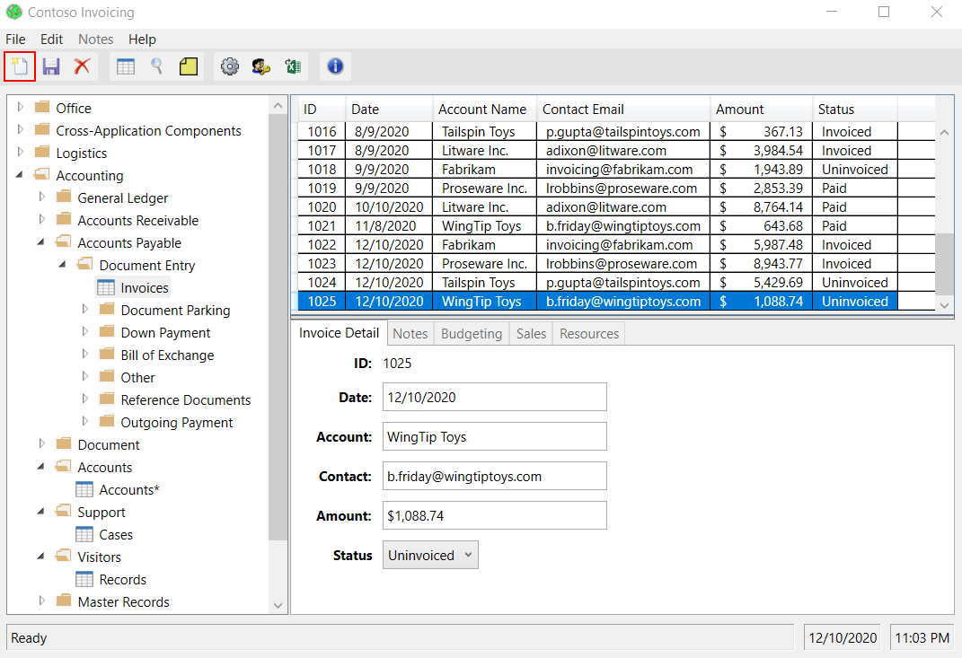

1. Use the following values to fill into the invoice detail fileds. (Note: you could also use any arbitrary values)

* Date: Current date
* Account: WingTip Toys
* Contact: b.friday@wingtiptoys.com
* Amount: $500
* Status: Invoiced

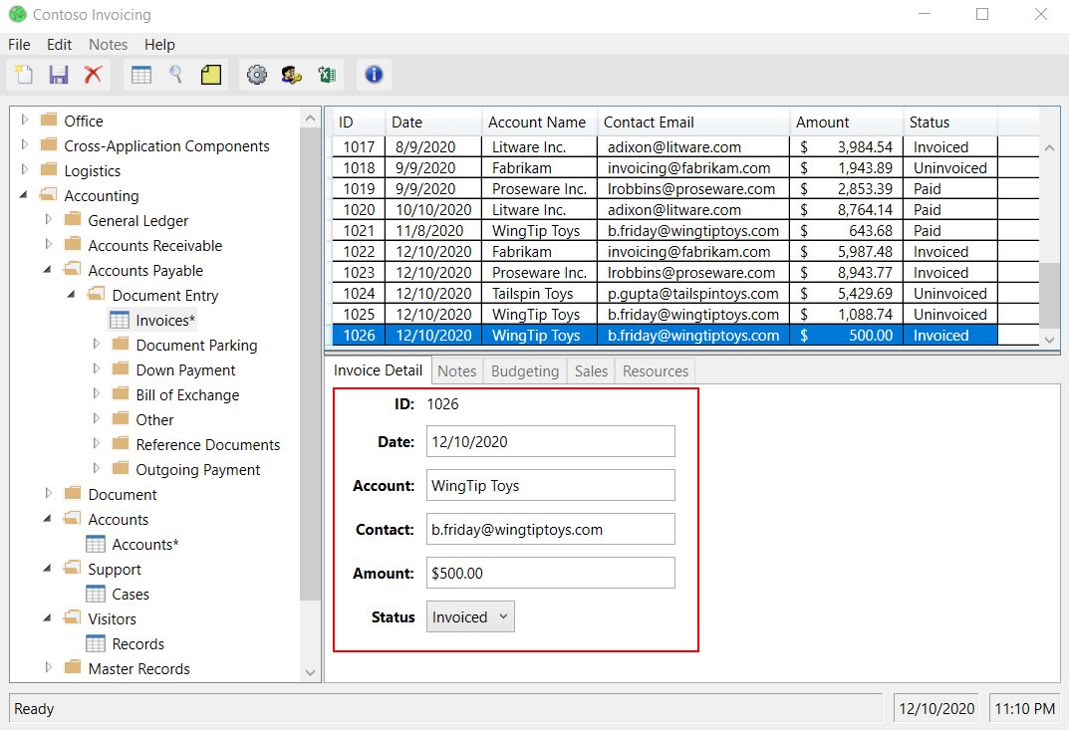

1. Click Save icon to keep your changes

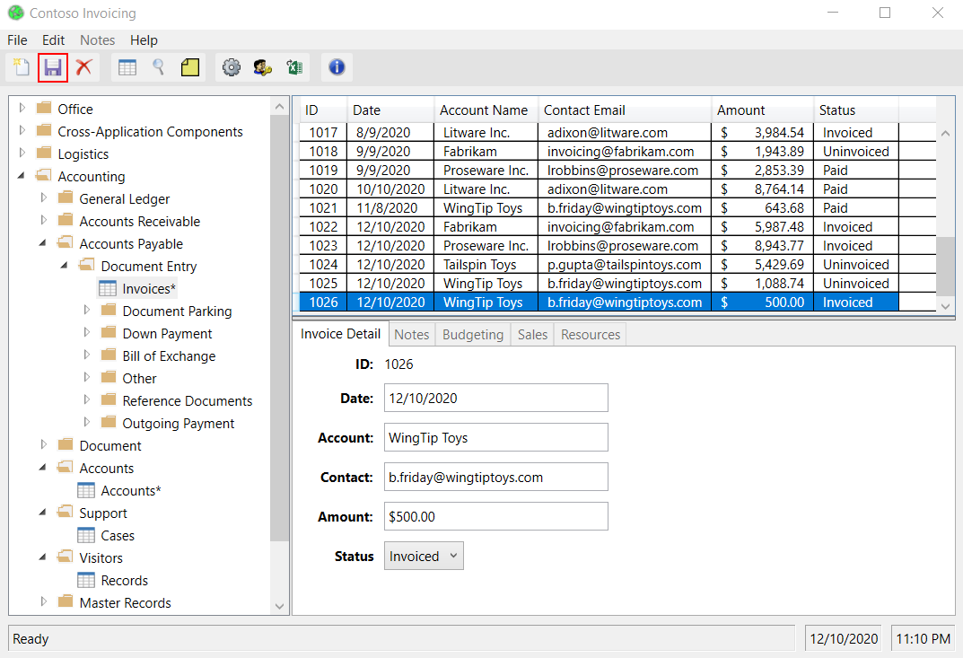

1. Click Finish button in the Desktop recorder

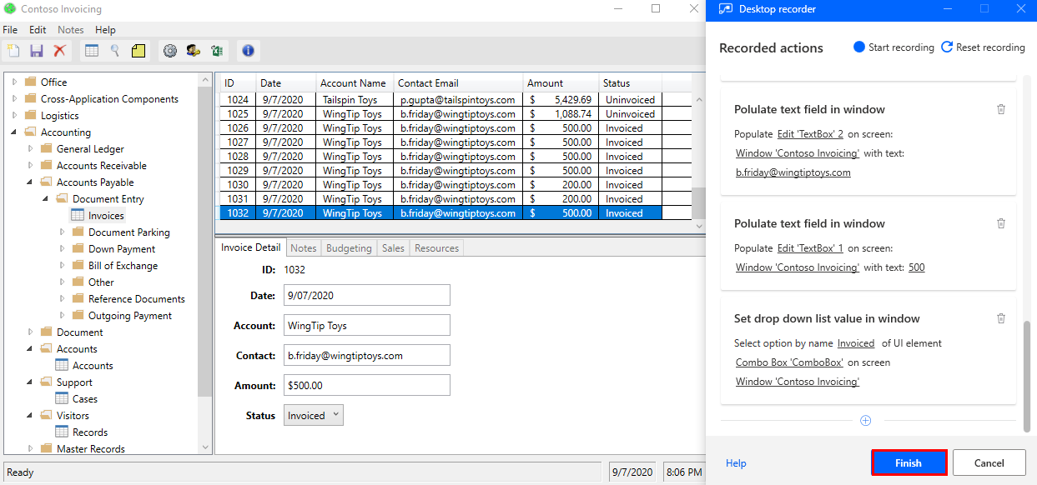

1. Close the Contoso Invoicing app.

Note: We did not record closing the app. This is for simplicity to view the result as the Contoso app will remain open after we test the Desktop flow. In a real-world use case, you can decide to record the closing step or not.

Note 2: By default, the Desktop flow will launch a new instance of the app every time when it runs. Even if you leave the app open, the next Desktop flow run will launch another new app window. You can also change this behavior to only attach to existing app instead of launching another new instance from the portal (details on how to do it please see following steps).

1. You will see that your recording has been saved. This might take some time. After it is saved, click Got it

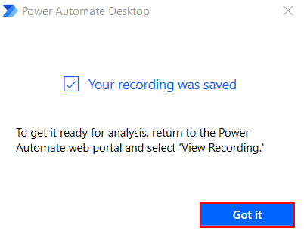

1. Go back to **Process advisor** and select View recording. This might take a few minutes to get ready.

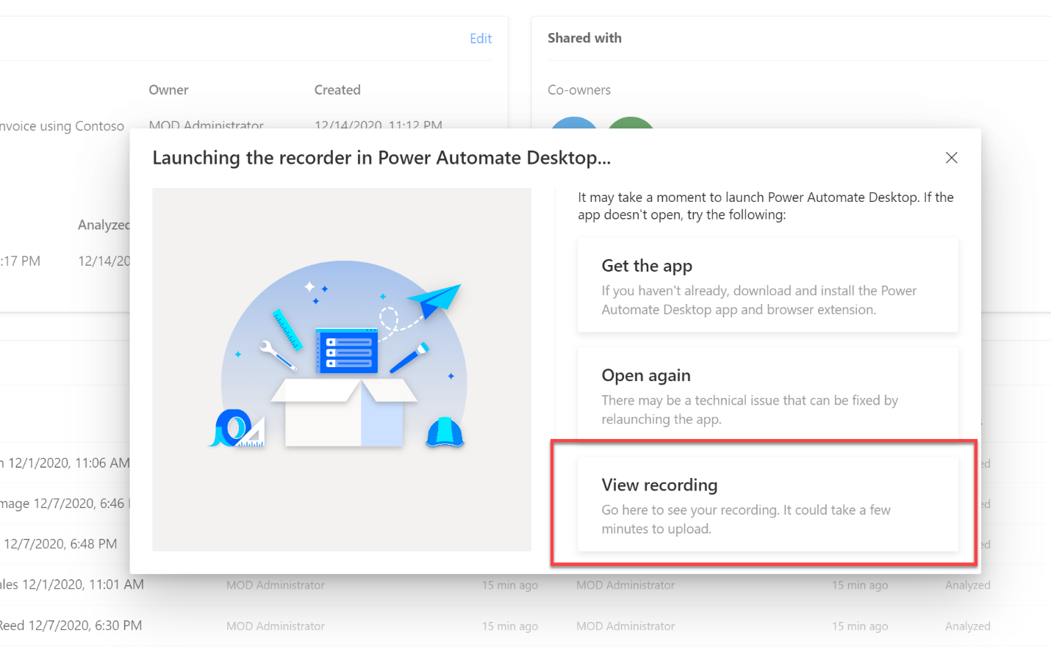

Note: if the windows is not present, navigate back to “Processes” and open “Invoice submission Processing”. Then click the last recording.

1. Now you will see your recording details. At which timestamp you have performed which step. Everything is recorded.

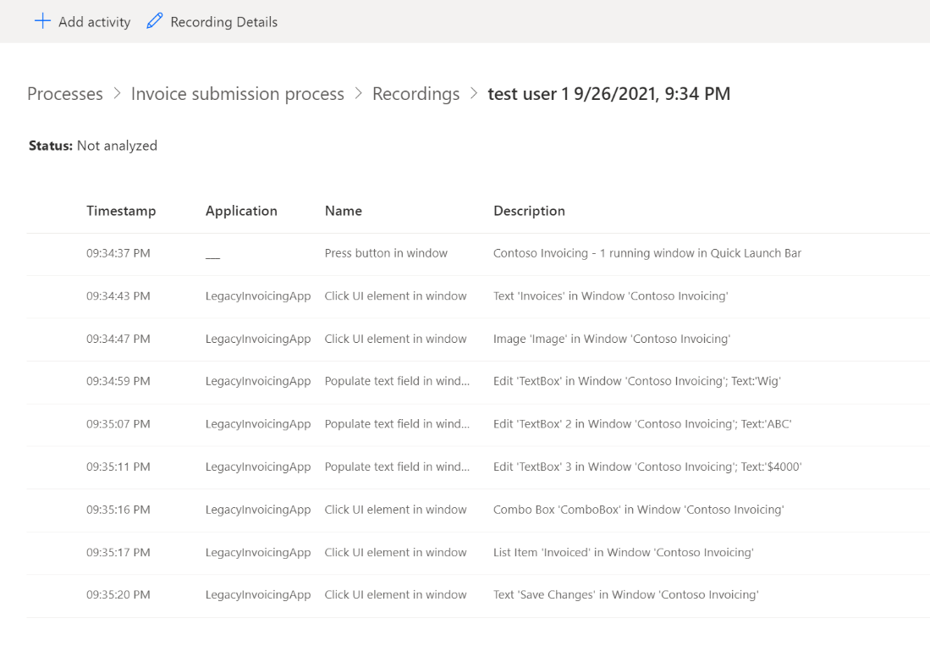

1. When you click on a specific action, you will be able to see a screenshot of that corresponding recorded action.

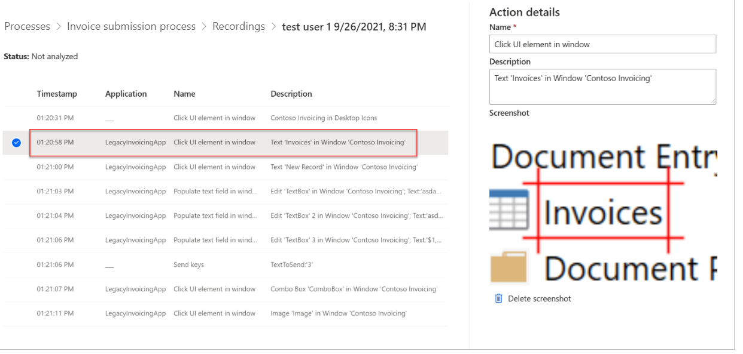

1. If you don’t want to save the screenshot, you can also delete your screenshots by clicking Delete screenshot on the right corner

Note: It will not affect your recordings analysis by deleting the screenshots.

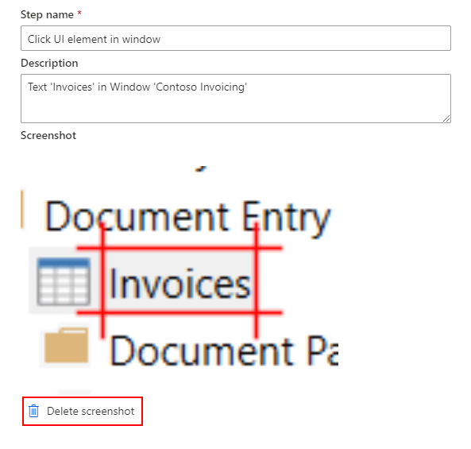

1. Long business processes may require the need to group related tasks to document or describe the overall business process. We can use a feature called activities that allows us to break up a large business process into smaller activities which enables better management. To label your first activity. Select + Add activity to add an activity header

Tip1: Since we are adding a recording to an existing process, we have some existing activities that are available for us to use. It is recommended you use existing activity name; this creates a more consistent and accurate process map.

Tip2: Activity names will be available in the dropdown list whenever a recording is saved. To remove activity names from the dropdown list after it was removed from all recordings that used that activity name, you need to analyze the recording.

Tips3: To analyze, you need at least two activities. Otherwise, the process map would not be very meaningful.

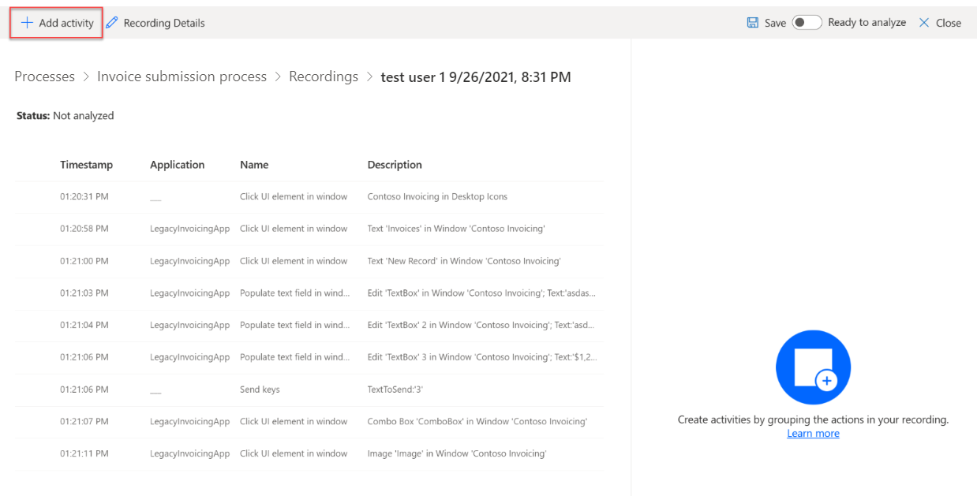

1. Let’s label step 1 to 8 as your first activity. Move the activity header above the first step. Here’s where you want your first activity to start.

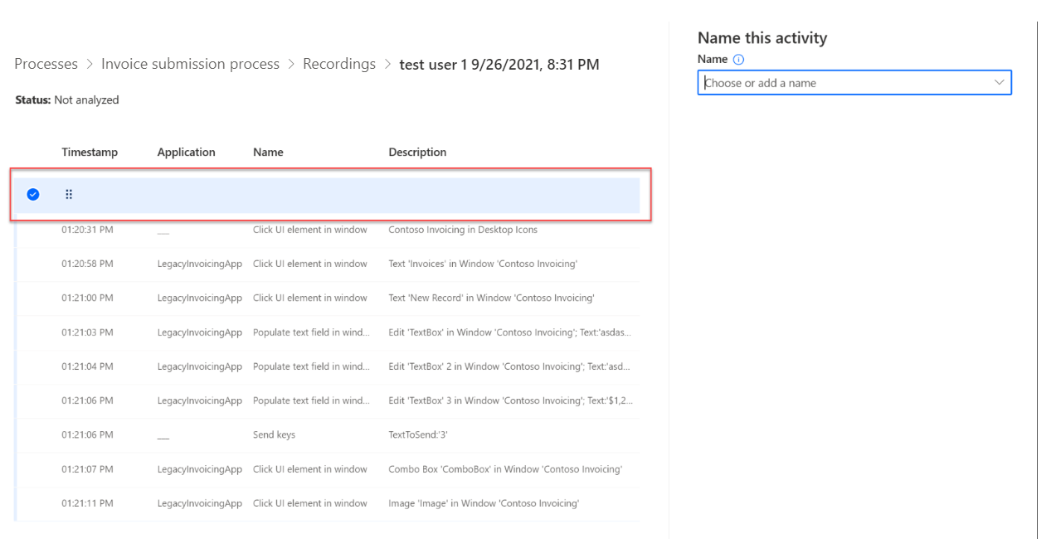

1. Name your first activity using the tab on the right side of the screen. You can use the dropdown menu to find the recommended activity names that already exist for the process or create your own name. For this Lab, we will use the existing activity name Enter invoice details.Select this name from the dropdown menu to name our first activity.

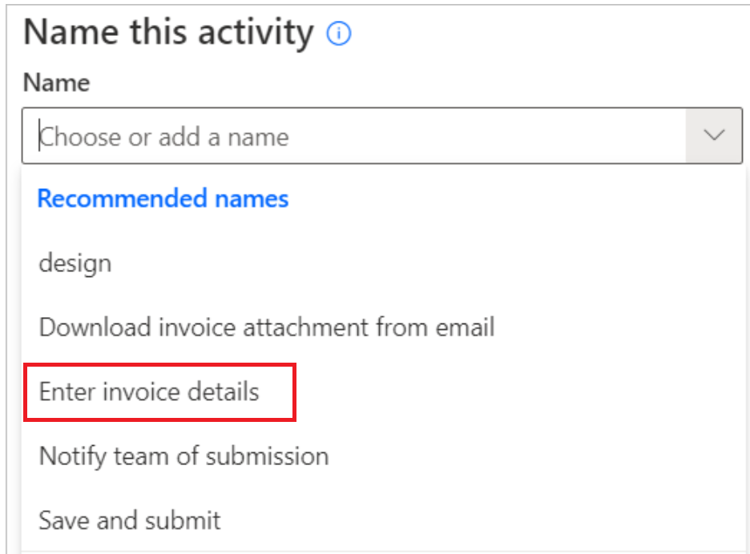

1. Should you make a mistake creating an activity name, you can always delete it by clicking on the trash can icon next to the + Add activity to delete an activity name. Otherwise, proceed to next step.

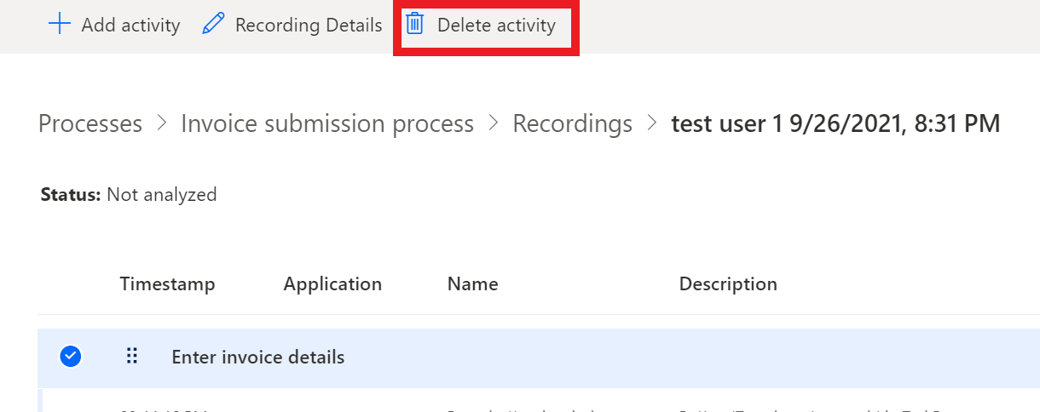

1. Select + Add activity to label your second activity.

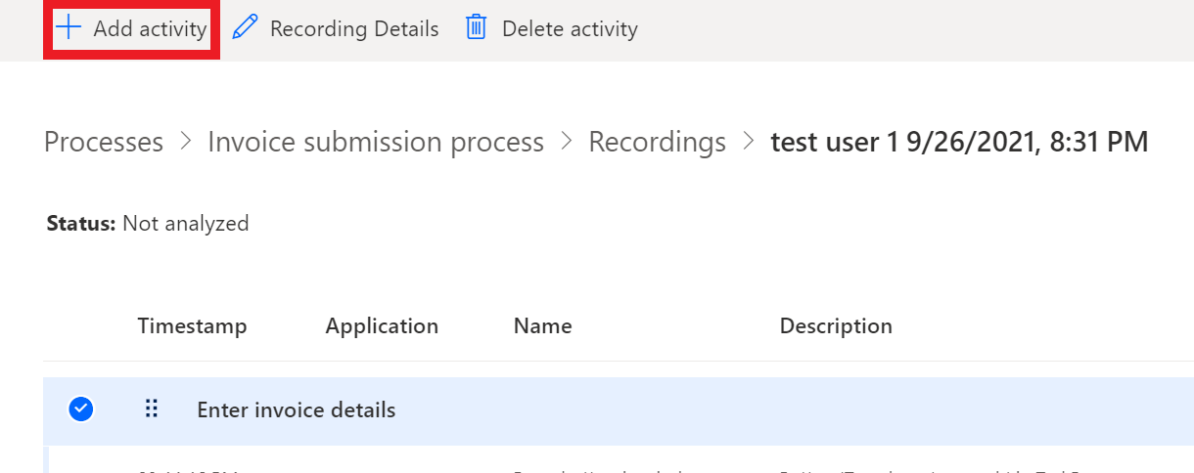

1. Let’s label the last step as your second activity. Move the activity header to above the last step which is click “Save change” in Window “Contoso Invoicing”. To do that, hold mouse on the “move the activity” icon and drag and drop it to the . Here’s where you want your second activity to start

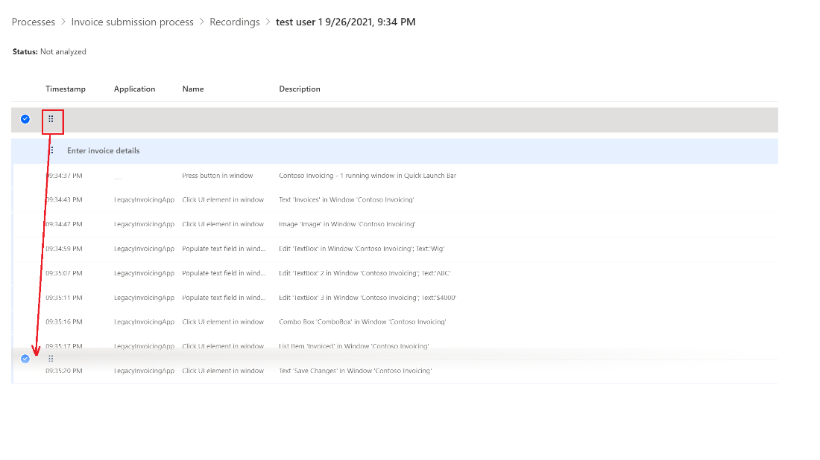

1. Now we will name the second activity. We are also going to use the existing activity name Save and submit from the dropdown menu to name our second activity.

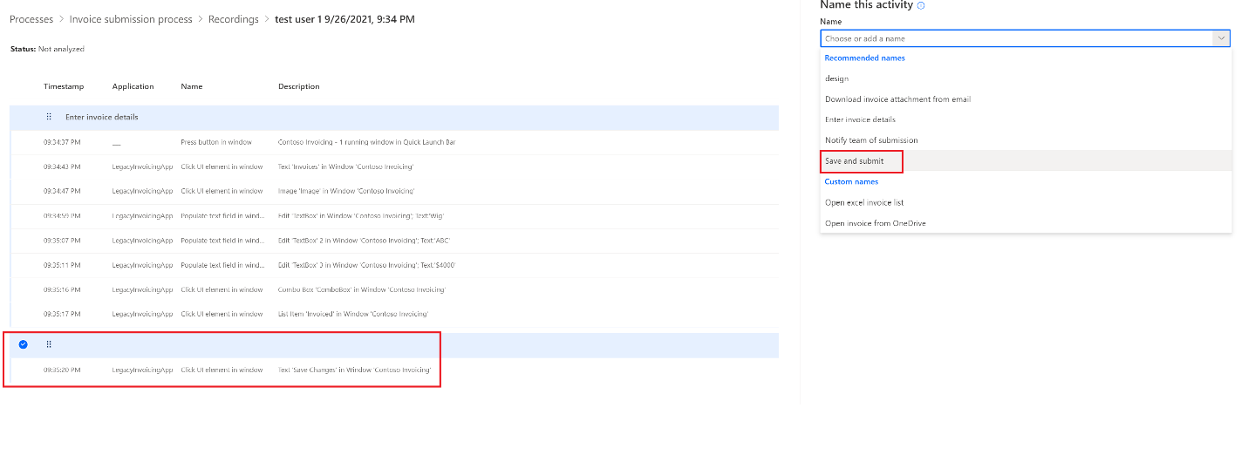

1. Click Save to save your changes

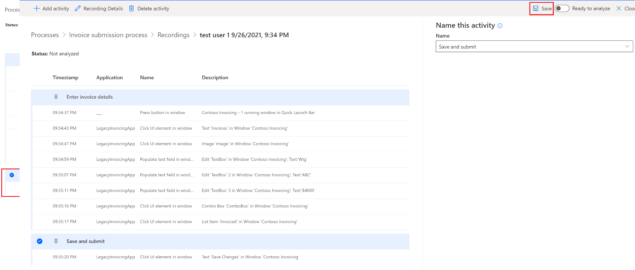

1. Your recoding is now ready to analyze. Toggle the Ready to analyze button.

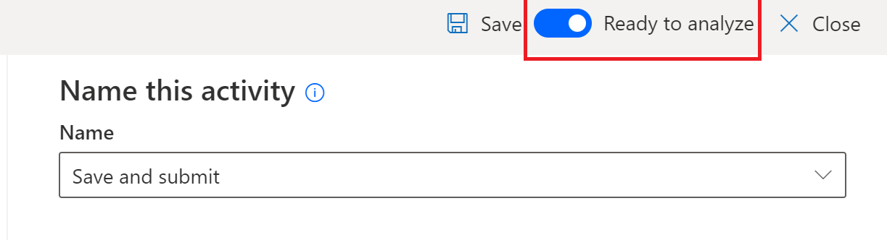

1. Click Save and then click Close button to return to the process details page

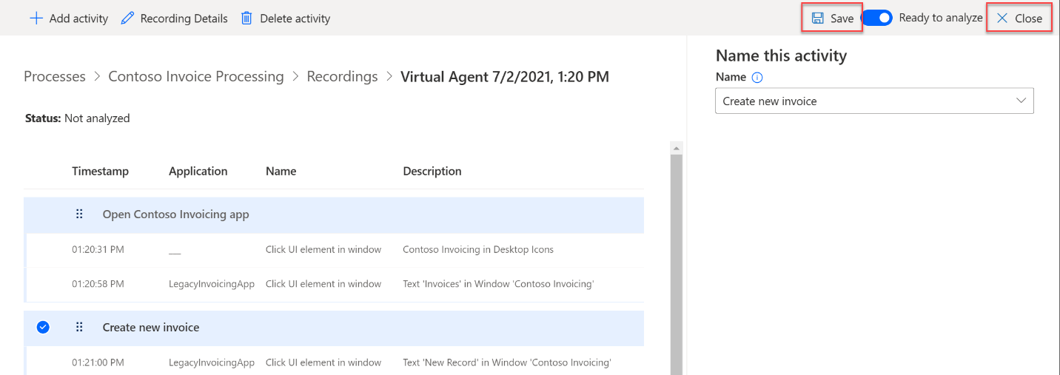

1. We are going to analyze your recording now, click Invoice submission process

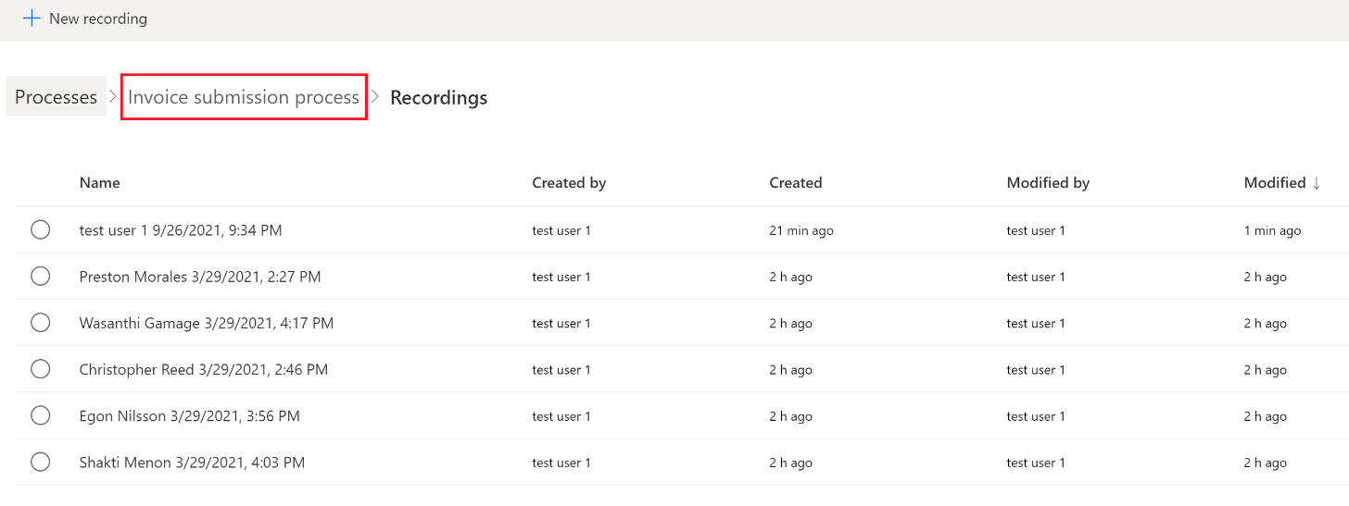

1. You can see that the status your recording is **Not a**nalyzed

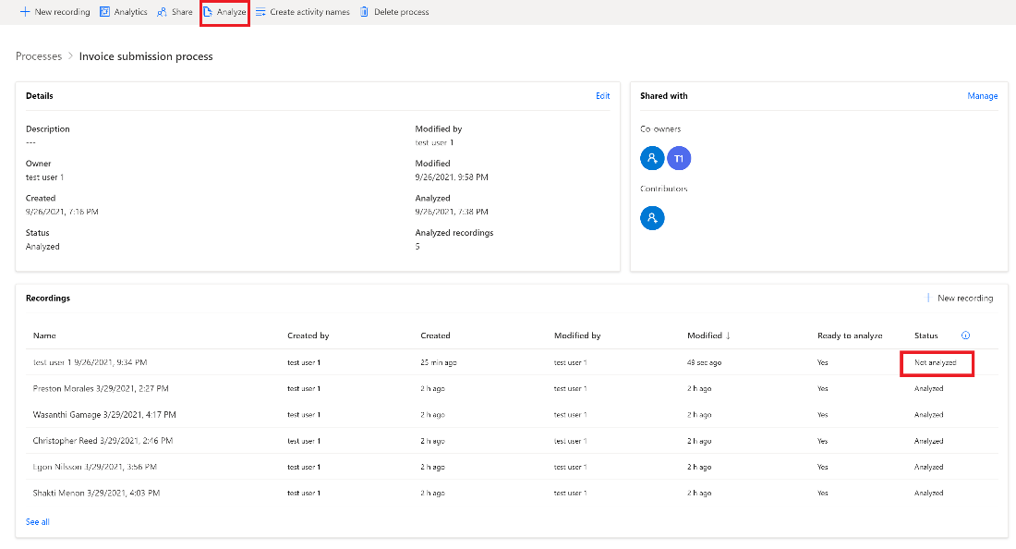

1. Click Analyze



1. Select Confirm



1. You can see that the status your recording has been changed to Analyzed

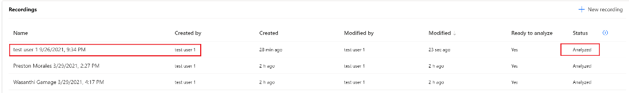

1. Click Analytics

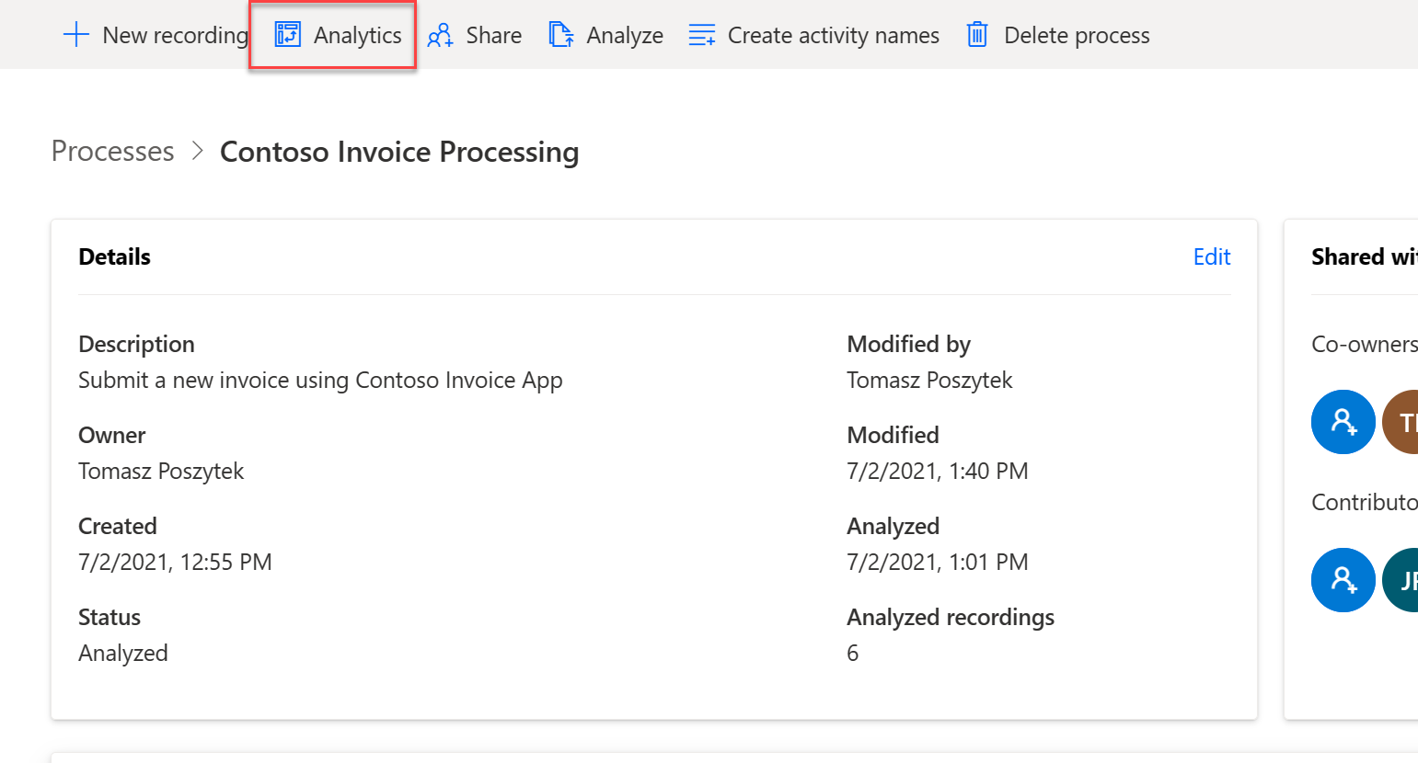

Note: This step may take a few minutes to load.

1. You can see your recording represented in the process map and the analysis.

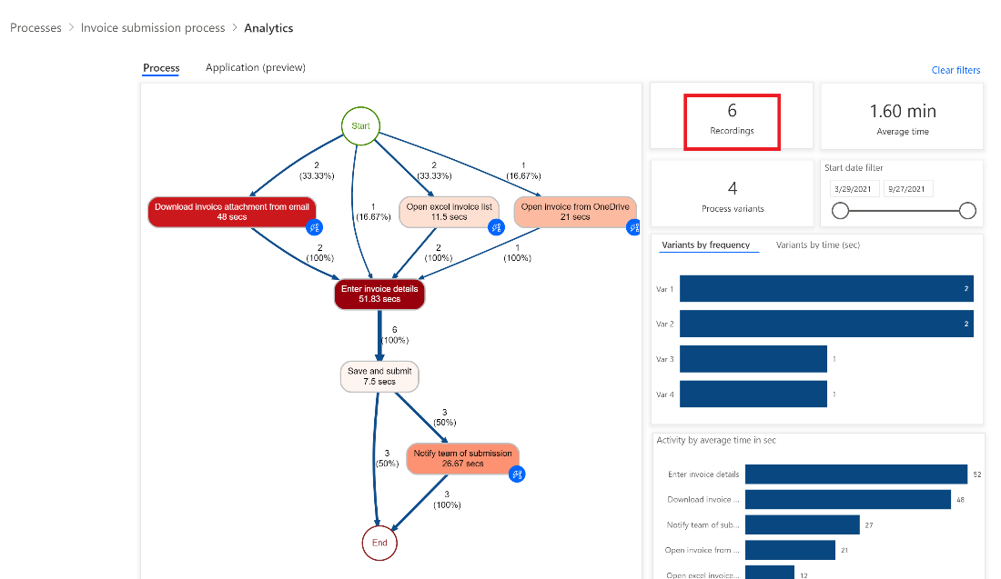

1. Let’s scroll down to see Activity by average time in sec and Recording by time in sec.

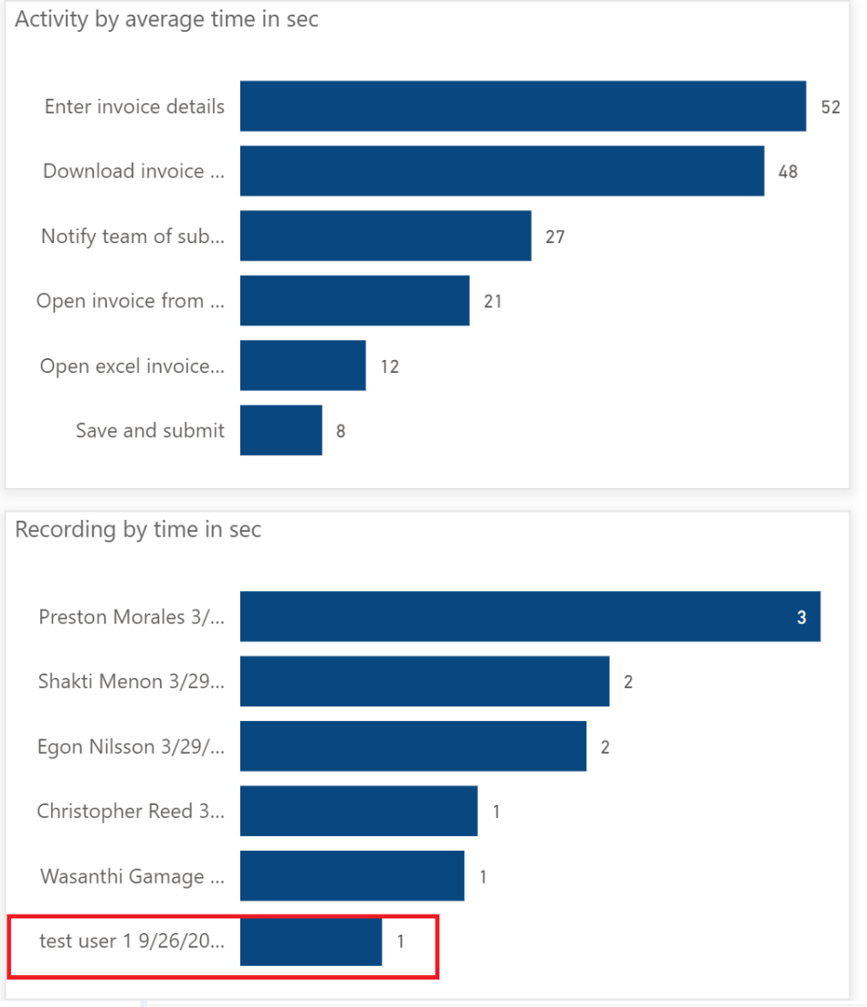

1. This highlights the importance of including people who regularly participate in your business process to get a complete picture of the bottlenecks, but also the opportunities that emerge for automation.

Note**:** Depending upon how long it took you to complete the actions, will determine where your record is located in the list.

1. This completes the Process advisor lab. Now that we understand where all the bottlenecks exist in our business process, we can now go ahead and automate them in subsequent labs using Power Automate.

Check your knowledge

Lab 2

5 minutes

1. Which of the following allows you to see the process map and insights?
2. Share
3. Analyze
4. Analytics
5. None of the above

Answer: C. The process map can be found within the Analytics feature.

1. When it comes to annotating your recording, how do you group related actions together?
2. Click Add activity
3. Click Application
4. Click Description
5. Click Timestamp

Answer: A. Click Add activity to group related actions together.

1. To analyze, how many activities do you need at least?
2. 1
3. 2
4. 3
5. 4

Answer: B. 2

Information in this document, including URL and other Internet Web site references,  
is subject to change without notice. Unless otherwise noted, the example companies, organizations, products, domain names, e-mail addresses, logos, people, places, and events depicted herein are fictitious, and no association with any real company, organization, product, domain name, e-mail address, logo, person, place or event is intended or should be inferred. Complying with all applicable copyright laws is the responsibility of the user. Without limiting the rights under copyright, no part of this document may be reproduced, stored in or introduced into a retrieval system, or transmitted in any form or by any means (electronic, mechanical, photocopying, recording, or otherwise), or for any purpose, without the express written permission of Microsoft Corporation.

Microsoft may have patents, patent applications, trademarks, copyrights, or other intellectual property rights covering subject matter in this document. Except as expressly provided in any written license agreement from Microsoft, the furnishing of this document does not give you any license to these patents, trademarks, copyrights, or other intellectual property.

The names of manufacturers, products, or URLs are provided for informational purposes only and Microsoft makes no representations or warranties, either expressed, implied, or statutory, regarding these manufacturers or the use of the products with any Microsoft technologies.  
The inclusion of a manufacturer or product does not imply endorsement of Microsoft of the manufacturer or product. Links may be provided to third party sites. Such sites are not under the control of Microsoft and Microsoft is not responsible for the contents of any linked site or any link contained in a linked site, or any changes or updates to such sites. Microsoft is not responsible for webcasting or any other form of transmission received from any linked site. Microsoft is providing these links to you only as a convenience, and the inclusion of any link does not imply endorsement of Microsoft of the site or the products contained therein.

© 2021 Microsoft Corporation. All rights reserved.

Microsoft and the trademarks listed at <https://www.microsoft.com/enus/legal/intellectualproperty/Trademarks/Usage/General.aspx>are trademarks of the Microsoft group of companies. All other trademarks are property of their respective owners.